NEWPORT BACK BAY (ESTUARY/SALT MARSH COMMUNITY) REPORT: 50 POINTS

I. Title Page (1 pt)
A. Title
B. Name, date, and location of field trip
II. Introduction - See your lecture textbook (Ch. 12) and the Coastal Wetlands: Estuaries and Salt Marshes handout on our course website for information on the following:
A. Discuss the following using complete sentences in paragraph format:
1. Definition of an estuary (2 pts)
2. Importance of estuaries - 5 functions or services that estuaries provide (5 pts)
3. Definition of a salt marsh (2 pts)
III. Photographs
A. Take a view point photograph of Newport Back Bay. Label the following on that photograph:
1. Open water community (1 pt)
2. Mudflat community (visible at low tide) (1 pt)
3. Salt marsh community (1 pt)
B. Plankton trawl activity
1. Define plankton and describe the differences between phytoplankton and zooplankton, and holoplankton and meroplankton (3 pts)
2. Take a picture of one species of phytoplankton and one species of zooplankton observed in the microscope (they can be in the same photo if you’re lucky). If you can’t get a good photo, use pictures taken from the web that match the species you observed. (4 pts together or 2 pts each photo)
a. For each species, list the kingdom, phylum, and common name, and state whether the organisms is considered phytoplankton or zooplankton. (3 pts each)
C. Mud grab activity
1. Take a picture of two species collected from the mud and provide the kingdom, phylum, and common name for each species (3 pts each).
3. For both species you identified in the mud grab, provide a few sentences on how the organism eats and the species that feed on the organism you selected. (3 pts each)
D. Coastal Sage Scrub: You need a photo of the coastal sage scrub habitat that surrounds the estuary (2 pts)
E. Wildlife: You may use your own photographs, pictures from the web, or images from books (cite images from web and/or books) (10 points)
1. Take a photograph of five animals you saw during the trip. Under the photograph, provide the common name of each species and describe the distinguishing features that helped you identify each animal.

Some web sites for bird photos are:
http://www.backbaybirds.com/names/
http://www.whatbird.com/
http://imnh.isu.edu/digitalatlas/bio/birds/main/birdid.htm
http://www.virtualbirder.com/vbirder/gallery/index.html

IV. Your work must be typed, neat, and well organized. If it is not you may lose 5 to 10 points related to the degree of disorder.

Example photographs:
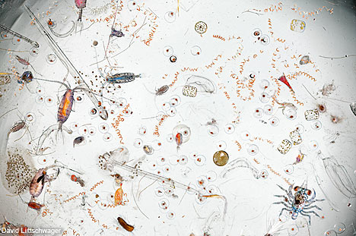

Zooplankton
Kingdom: Animalia
Phylum: Arthropoda
Common name: Copepod

Phytoplankton
Kingdom: Protista
Phylum: Diatom
Common name: Cerataulina

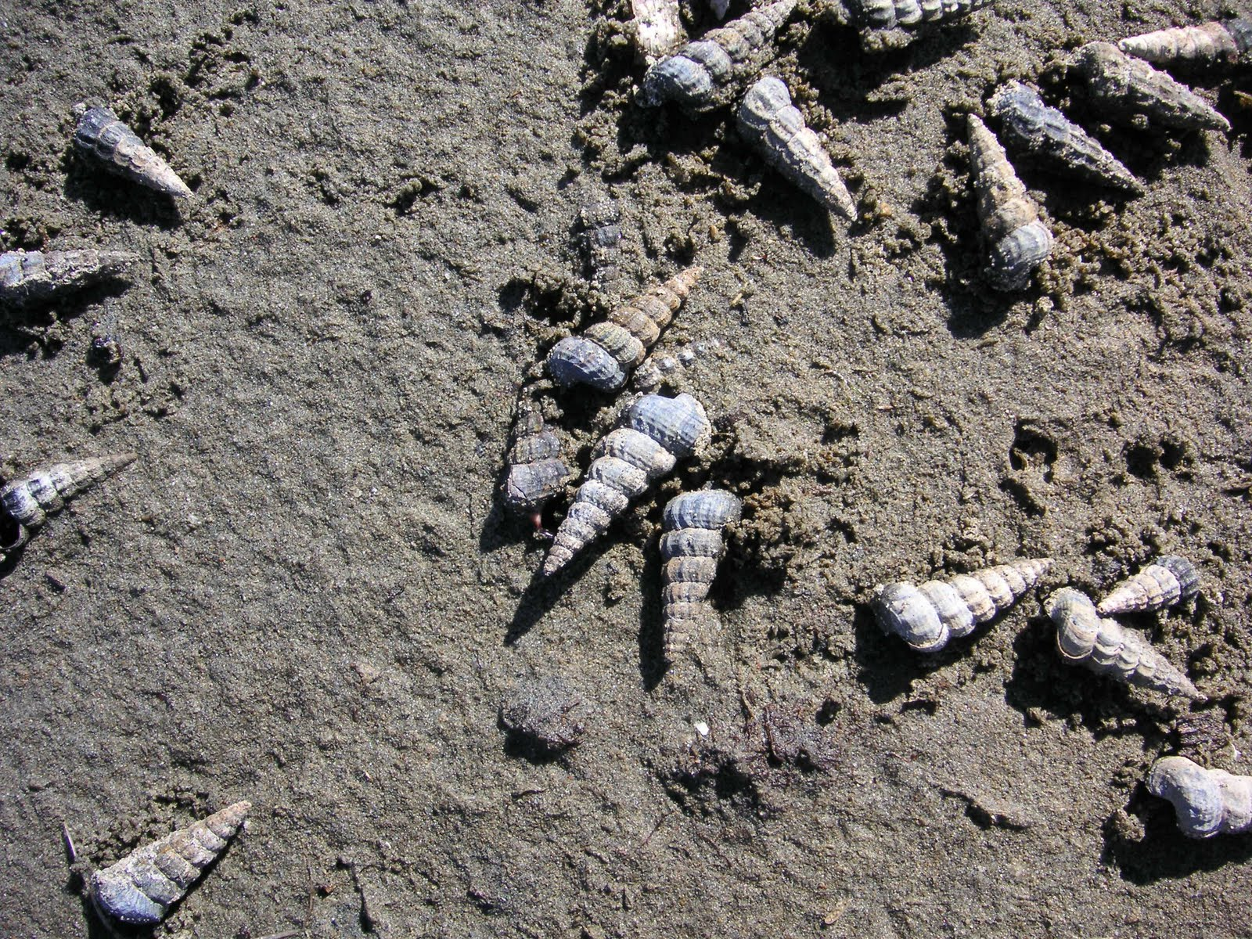

Kingdom: Animalia
Phylum: Mollusca
Common name: California horn snail

The California horn snail in dominant species in the mudflat community in the Newport Back Bay estuary. The snail feeds primarily on benthic diatoms and is an important food source for many shorebirds and crabs.

