Name___________________________
Homework Assignment #3 – DNA Replication and Protein Synthesis (5 pts)

What does DNA stand for? ____________________________________
What are the four nucleotides that make up DNA molecules? ________________________________________
DNA replication occurs during the ______________ phase of the cell cycle. During DNA replication, the enzyme ______________ unwinds the DNA double helix, while the enzyme ___________________ creates the complementary strand of DNA by adding new nucleotides to the template strand. The enzyme ______________________ only move in the 5’ to 3’ direction creating two different complementary strands of DNA. The ___________ strand grows continuously, whereas the __________ strand is replicated discontinuously as a series of DNA fragments.
In the space provided, write the complementary for the DNA sequence shown below.
ACCGTTGAATGCCCTAAGGTTAGTA
_______________________________________________________
What does RNA stand for? ______________________________________
What are the four nucleotides that make up RNA? ___________________________________________________
Protein synthesis begins in the nucleus of the cell where a strand of messenger ________ is synthesized from DNA by the enzyme ______________________ in a process known as ____________________. Before leaving the nucleus, the primary transcript goes through processing where non-coding sections of RNA called __________ are removed and the coding sections known as _________ are strung together to form a completed sequence of mRNA. After leaving the nucleus, the mRNA binds with a _____________ in the cytoplasm.
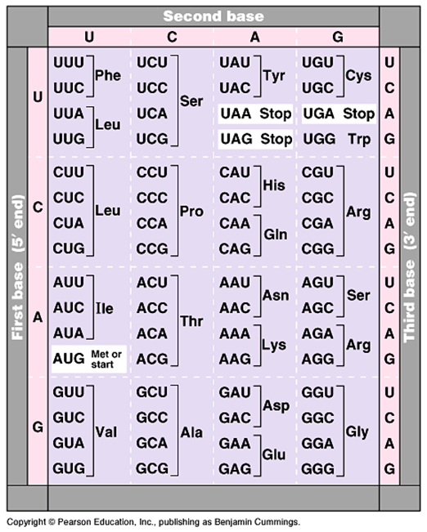
Using the DNA sequence listed below, first write the sequence for the mRNA then write the correct amino acid sequence using the mRNA.
DNA sequence: ATGCGATGAACGTCC
mRNA sequence:
Polypeptide:

Using the DNA sequence listed below, first write the sequence for the mRNA then write the correct amino acid sequence using the mRNA.
DNA sequence: TACGCACTTATCGGC
mRNA sequence:
Polypeptide:

A mutation that changes the DNA sequence from TACTAATGTGGC to TACTAATGAGGC it is a considered a ______________ mutation.

Using the DNA sequence below, create the corresponding sequence of mRNA, then process the mRNA by removing the introns (bold bases). After determining the sequence of the processed mRNA, create the correct polypeptide from the processed section of mRNA. Which of the following polypeptides are the result of the processed section of mRNA?
DNA sequence: CGCAAGTACCTTCGAAACGAAGCA
Unprocessed mRNA sequence:
Processed mRNA sequence:
Polypeptide:

Fill in the missing terms in the figure below
Name this process
Name this enzyme
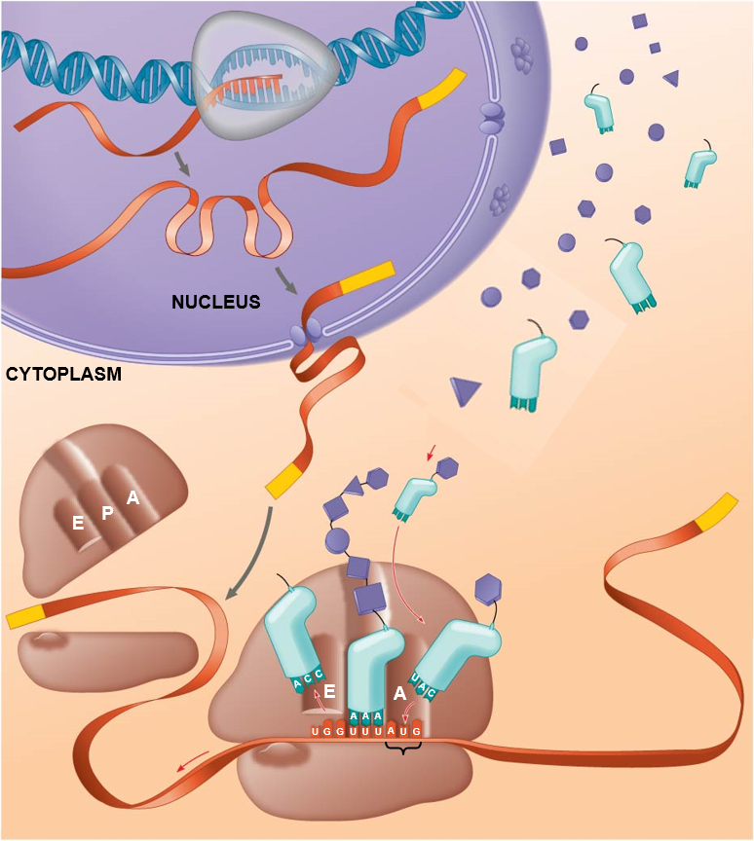

Name this molecule
Name this molecule
Name this “chain” of molecules
Name this part of the organelle
Name this organelle
Name this molecule
Name this process
Name this three-base sequence
Name this part of the molecule

