Name_____________________________

Homework #4: Circulatory System and Nervous System (5 pts)

Write the correct term in the space provided
Blood is transported away from the heart through the ___________ and back to the heart through the ___________.
The small, thinly walled vessels where gas, nutrient and waste exchange occur are known as __________________.
Blood flow between the heart and lungs occurs within the ______________ circuit, while the blood flow between the heart and the tissue in the body is known as the ________________ circuit.
The period of heart contraction when blood is pumped out of the ventricle is known and the __________ period, and the period of heart relaxation when the ventricles are filling with blood is known as the ___________ period.
An increase in blood CO2 levels due to exercise will result in a(n) _____________ in blood pH, which will cause sensors in the circulatory system to signal the medulla oblongata in the brain to ______________ the breathing rate.

In the diagram below, label the valves, heart chambers, and major arteries and veins entering or leaving the heart. Draw the pathway of deoxygenated and oxygenated blood as they move through the heart.
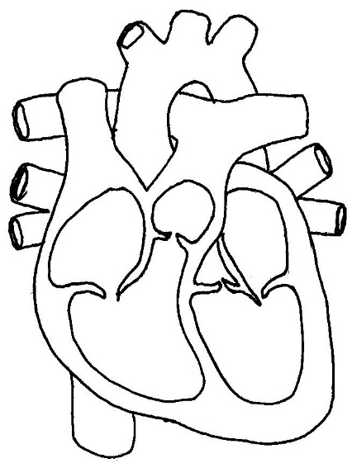

Fill in the table below on the differences between an open and closed circulatory system.
 | Open Circulatory System | Closed circulatory system
Type of fluid
Vessels present
Efficiency
Speed and control
Example organisms with this system

In the neuron below, label the different parts of the neuron and briefly describe the function of each part in the space provided.
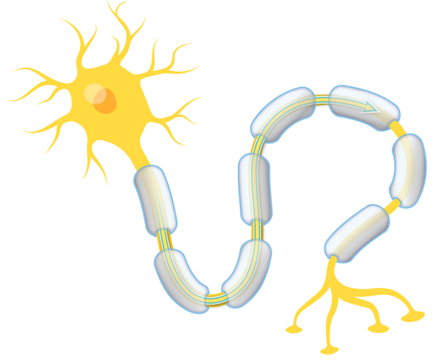

Axon: extension of neuron that transmits the action potential to other neurons

Write in the correct term in the space provided.
The brain and spinal cord are part of the ______________ nervous system, while the sensory organs are part of the __________________ nervous system.
Neurons that transmit signals from the sensory neurons to the brain are known as ____________ neurons, and the neurons that transmit signals from the brain to the muscles or organs are known as _____________ neurons.
The portion of the nervous system that allows for voluntary control of skeletal muscle is known as the ______________ nervous system, whereas all portion of the nervous system that controls involuntary boy function, including breathing and digestion, is known as the _________________ nervous system.
During normal, relaxed conditions your organs are controlled by the __________________ nervous system, however, when you are frightened, your _________________ nervous system takes over so that your body can respond to the stimulus.

In the space below, describe the steps involved in the propagation of an action potential through the neuron. Be sure to describe the changes in the membrane potential, and function of the ion channels and the sodium potassium pump.

