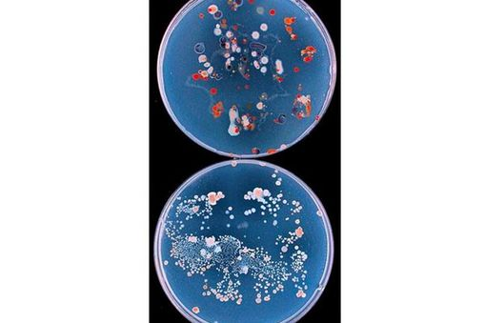

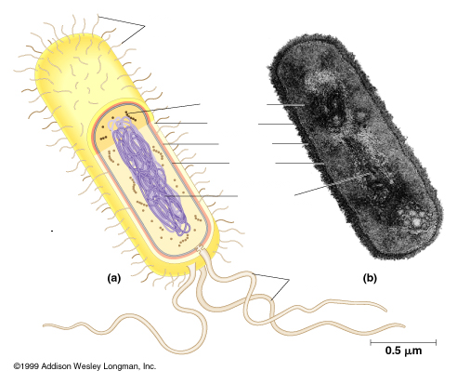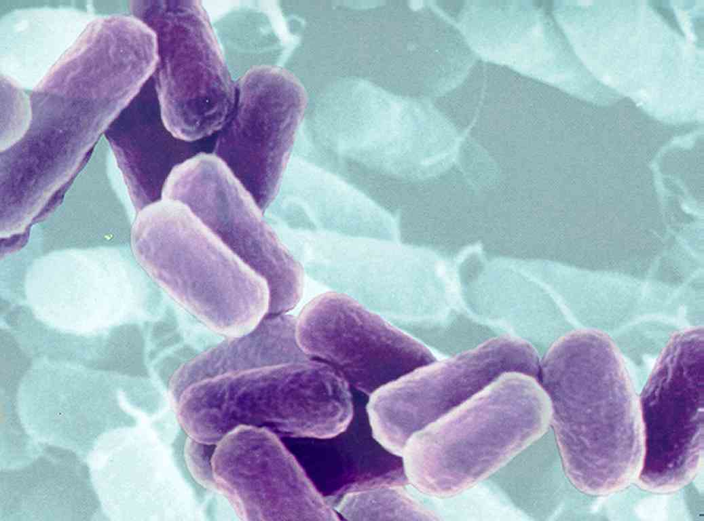

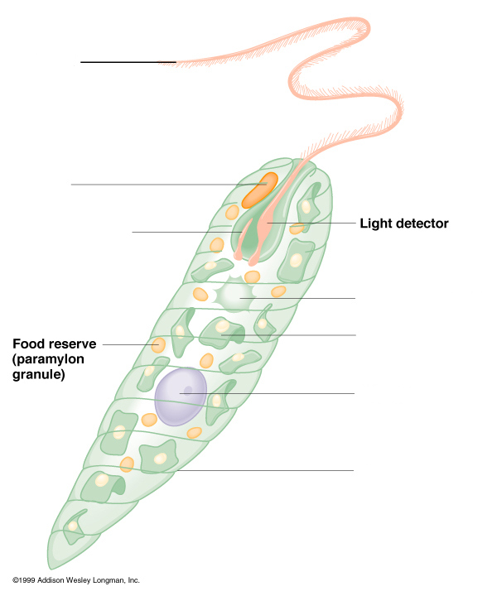

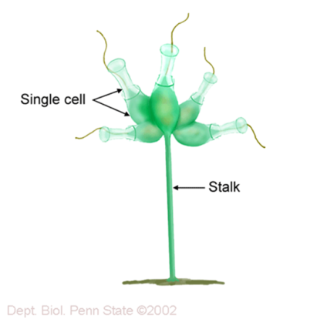Biology 2

Lab Packet

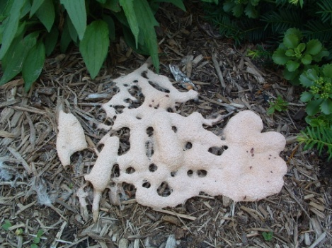

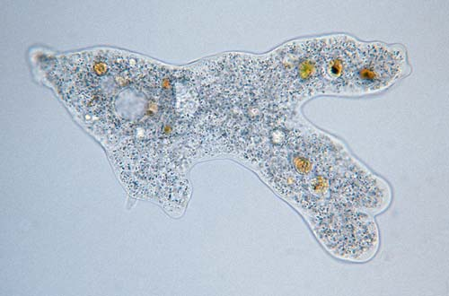For

Practical 1

****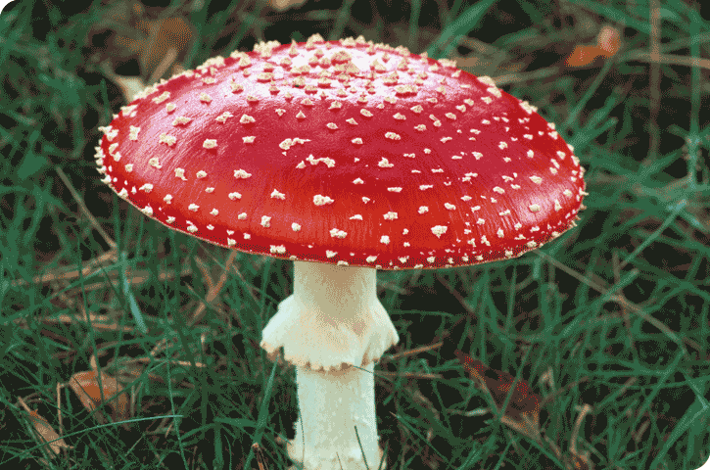

**CLASSIFICATION**:

**Domain: Bacteria Domain: Archaea**

Group: Proteobacteria Group: Methanogens

Group: Chlamydias Group: Halophiles

Group: Spirochetes Group: Thermophiles

Group: Cyanobacteria

Group: Gram-Positive Bacteria **Viruses**

# Station 1 – Prokaryotic Cells

### What general characteristics and structures are found in the clade Prokaryotes?

1. When did the first prokaryote appear in the fossil record?
2. What form did the fossil Prokaryote take?
3. How long were prokaryotes on earth by themselves?
4. Where are prokaryotes found?
5. Be able to label the diagram below.

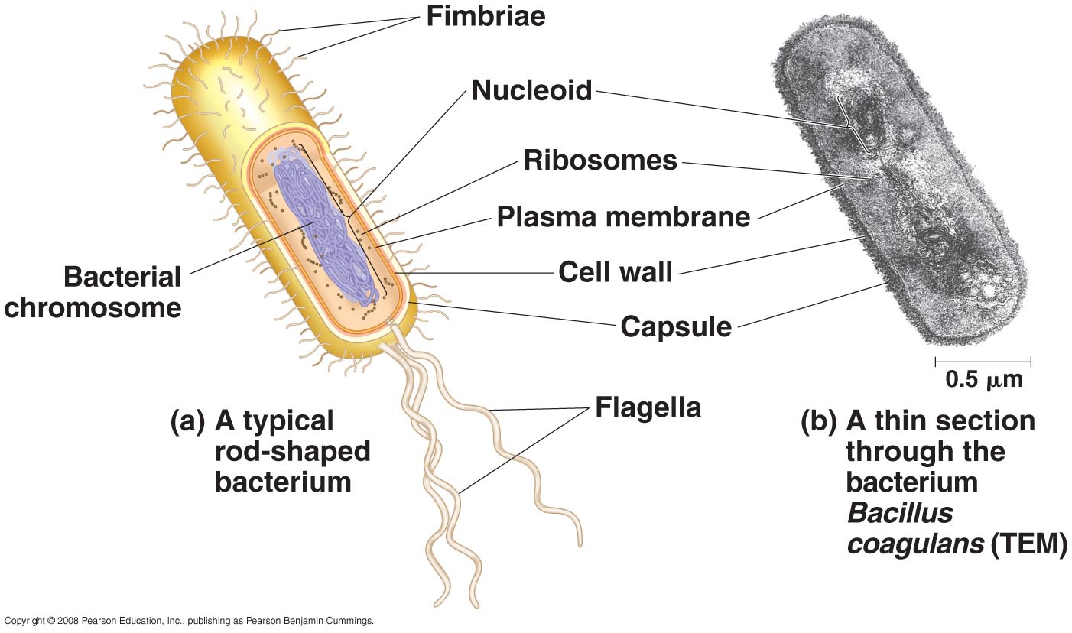

**Station 2 – Bacterial Shapes**

Be able to identify the following **shapes: Coccus, Bacillus, Helical and Filamentous**

Use the slide of *Streptococcus lactis* (in a chain) to become familiar with this shape.

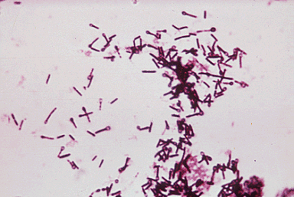 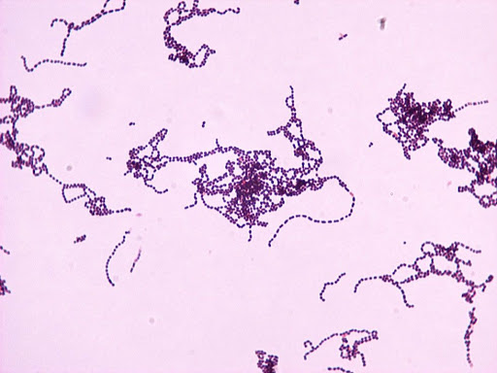

*Streptococcus lactis Clostridium tetani*

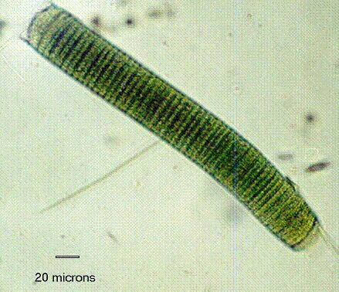

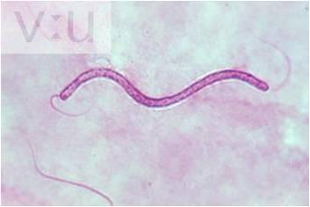

*Spirillum volutans Oscillatoria sp.*

## Station 3 – Gram Stain (Gram Positive and Gram Negative)

Be able to recognize the difference between a slide that is gram-positive and one that is gram-negative.

1. What do cell walls of prokaryotes contain?
2. What is the structure of the cell wall in gram-positive bacteria? What color does it Gram Stain?
3. What is the structure of the cell wall in gram-negative bacteria? What color does it Gram Stain?

## Station 4 – Bacterial Colonies

## When growing on a nutrient medium which has been hardened with agar (a derivative of red algae), each species of bacteria will form a characteristic colony that can be identified. A colony is a cluster of millions of bacteria. Observe the Petri dishes that have been contaminated with bacteria. Note the colonies vary in size, shape and color. They usually have a smooth or glossy surface, unlike mold (fungi) colonies, which have a fluffy, cottony, or filamentous appearance. Their height, edges or color may identify colonies. Be able to recognize that these are bacterial colonies. You will not be asked to know the different terms on the station card (round, wavy, wrinkled, etc.) or the type of bacteria colony.

#### Station 5 – Bacteria and Antibiotics

## Observe the Petri dishes that contain antibiotic discs. Antibiotics are used to treat infections because they inhibit growth of the bacterial colony. Each disc contains a different antibiotic. A clear area denotes the inhibition of bacterial growth. You will not be asked to recognize any specific antibiotic and how it works on any specific bacteria.

1. What characteristics allow antibiotics to work on bacterial cells but do not affect eukaryotic cells?

#### Do the same antibiotics work differently on different colonies of bacteria?

#### How does this affect the use of antibiotics to fight disease?

1. What is a narrow spectrum antibiotic?
2. What is a broad spectrum antibiotic?

## Station 6 – Bacterial Pigments

1. What are the reasons that some bacteria are pigmented?
2. Be able to recognize the pigmented bacteria located at this station.

## Station 7 – Luminescent Bacteria

1. Where can luminescent bacteria be found?
2. What enzyme do these species have that allows them to give off light?
3. What industrial application do these bacteria serve?

#### Station 8 – Prokaryote Classification

1. What did Carl Woese use to separate the kingdom Monera into different domains?
2. What are the major groups included in the Domain Bacteria?
3. What were the first Archaea called? What were the two types?
4. What is the name of the group in the more moderate environments?

**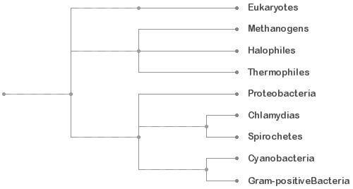**

Archaea Bacteria

**Station 9 – Domain: Bacteria Classification**

1. The Scientists interested in the evolution of microorganisms are more interested in using what technique to determine classification? What test do they use to analyze these genes?
2. What ability does bacteria have that make classification difficult?
3. What is the average % of the bacterial genome made by this process?
4. What phenotypic typing schemes do clinicians and clinical microbiologists rely on for identifying bacterial species?

**Station 10 - Domain: Bacteria Group: Proteobacteria**

1. How is this group divided into subgroups?
2. Be able to answer the following questions about the example *E. coli* **(You will not be asked to identify *E. coli* by sight)**
3. Is *E. coli* gram-positive or gram-negative?

1. What are the oxygen requirements of *E. coli*?
2. What shape does *E. coli* demonstrate?
3. Where can *E. coli* be found?
4. What structure do some of the pathogenic strains have?
5. What are the causes of outbreaks of *E. coli* in the United States?

**Station 11 – Domain: Bacteria Group: Chlamydias**

1. What shape do these organisms demonstrate?
2. 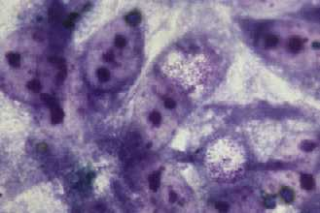Where are these organisms found?
3. How are these organisms transmitted?
4. Is this group Gram-positive or Gram-negative?
5. What is lacking in the cell wall of this group?
6. Why don’t we have an example of this group?
7. Know the example ***Chlamydia*** *trachomatis*.
8. What two problems are associated with *Chlamydia trachomatis*?

**Station 12 – Domain: Bacteria Group: Spirochetes**

1. What shape do these organisms demonstrate?
2. What are the nutritional requirements for this organism?
3. What is the name of the special structure involved in this group’s movement?
4. Be able to recognize the example ***Treponema pallidum***
5. What disease does *Treponema pallidum* cause?

1. What are the four stages and symptoms of this disease?

Stage 1 - Stage 3 -

Stage 2 - Stage 4 -

1. How is this disease transmitted and what are the requirements for transmission?
2. What is the oxygen requirement for *Treponema pallidum*?

**Station 13 – Domain: Bacteria Group: Cyanobacteria**

1. What are the nutritional requirements for most of the bacteria in this group?
2. What are the oxygen requirements for the bacteria in this group?
3. What is the name of the pigment that gives the bacteria in this group their blue-green color?
4. What are the two processes that are only found together in this group of organisms?
5. Be able to recognize the prepared and live examples of ***Oscillatoria***
6. Where can *Oscillatoria* be found?
7. What shape does *Oscillatoria* demonstrate?
8. What causes *Oscillatoria* to go through a “bloom”?
9. What is the eventual outcome of these “blooms”?

## Station 14 – Domain: Bacteria Group: Gram-positive bacteria

1. What type of gram stain do most of the bacteria in this group demonstrate?
2. What are the nutritional requirements for most of the bacteria in this group?
3. Be able to recognize the example of ***Clostridium tetani***
4. Is *Clostridium* gram-positive or gram-negative?
5. What are the oxygen requirements of *Clostridium*?

Endospore

1. What shape does *Clostridium* demonstrate?



1. Where can *Clostridium* be found?
2. What is the function of the endospore?
3. What type of toxin does *Clostridium* release?
4. What disease does *Clostridium tetani* cause?

**Station 15 – Classification**

**Domain: Archaea**

1. What are the three groups in this domain and how are they separated?
2. What types of cells make up these organisms?
3. What characteristics do these organisms have in common with eukaryotes?
4. What are these organisms most closely related to?
5. Know the example slide for this domain (**You will not be asked to identify Archaea by sight**)

**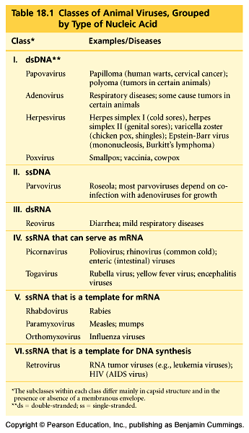Station 16 – Viruses**

1. What are viruses made up of? What are the 6 different forms

of nucleic acid found in viruses?

1. 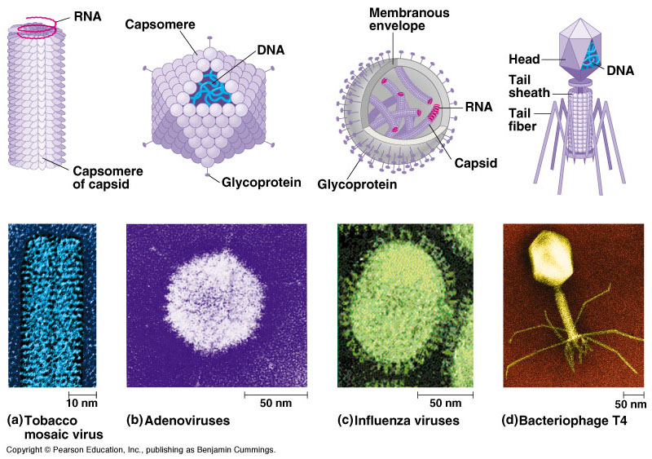What size are they?

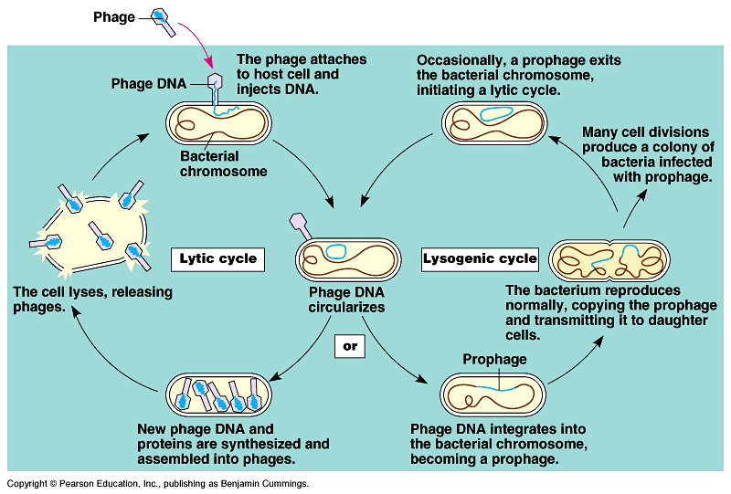

1. How do viruses reproduce? What are the two cycles?

How do they differ?

**CLASSIFICATION**:

**Domain: Eukarya**

**Supergroup: Excavata Supergroup: Archaeplastida**

Clade2: Diplomonads Clade2: Rhodophyta

Clade2: ParabasalidsClade2: Chlorophyta

Clade2: Euglenozoans Clade2: Charophyta

Clade3: Euglenids **Supergroup: Unikonta**

Clade3: KinetoplastidsClade1: Amoebozoans

**Supergroup: SAR** Clade2: Slime Molds

Clade1: AlveolatesClade3: Plasmodial

Clade2: Dinoflagellates Clade3: Cellular

Clade2: Apicomplexans Clade2: Gymnamoebas

Clade2: Ciliates Clade2: Entamoebas

Clade1: Stramenopila Clade1: Opisthokonts

Clade2: BacillariophytaClade2: Nucleariids

Clade2: Chrysophyta Clade2: Choanoflagellates

Clade2: Phaeophyta

Clade2: Oomycetes Clade 1: Rhizaria

Clade2: Cercozoans

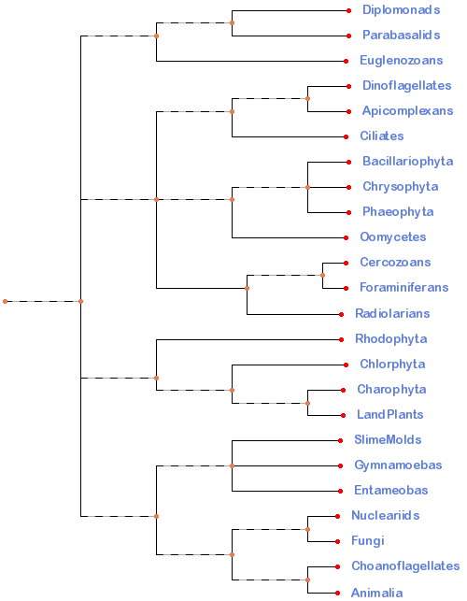Clade2: Foraminiferans

Clade2: Radiolarians

# INTRODUCTION FOR PROTISTA

The kingdom Protista (in the five kingdom system) contains mostly unicellular eukaryotes. This taxonomic grouping is polyphyletic and based only on cellular structure and life styles not on any molecular evidence. Using molecular biology and detailed comparison of cell structure, scientists are now beginning to see evolutionary history in the protists. The following classification suggests 4 “supergroups” within the original protista kingdom and the taxonomy is still being worked out. This lab is looking at one current hypothesis shown on the right. Some of the organisms are grouped together because of very strong support. It is important to focus on the characteristics of each clade which explains why they are grouped together. This lab will only look at the groups that were once included in the Protista kingdom and the other groups (higher plants, fungi, and animals) will be examined in future labs. Starting with the four “Supergroups”, we will divide the rest into different levels called clades. A Clade is defined as a group of biological taxa (as species) that includes all descendants of one common ancestor. Too simplify this process, we have included a cladogram we will be using throughout the course. We will divide or expand parts of the cladogram to emphasize evolutionary relationships. For the protists, we will divide the supergroups into smaller clades assigning them artificial numbers (clade1, clade2, clade3) to establish a grouping at a specific level.

Excavata SAR Archaeplastida Unikonta

Alveolata Stramenopila

Amoebozoans Opisthokonts

Ancestral Prokaryote

**Station 17 - Protista**

### What general characteristics and structures are found in the Clade Protista?

1. When did the first Protista appear in the fossil record?
2. What form did the first Protista take?
3. What is the name of the hypothesis that suggests that mitochondria evolved before plastids through a series of endosymbiotic events?
4. Where are protists found?
5. What are the major factors restraining their spread?

## Station 18 - Supergroup: Excavata

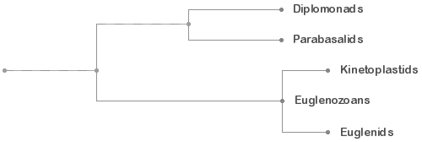

1. What characteristics are found in the supergroup Excavata?
2. Why is it hard to determine if this supergroup is monophyletic?
3. What type of taxa does this supergoup include?
4. What are the three clades included in this supergroup?

**Station 19 – Clade2: Diplomonads**

1. What are the general characteristics of the Clade Diplomonads?
2. 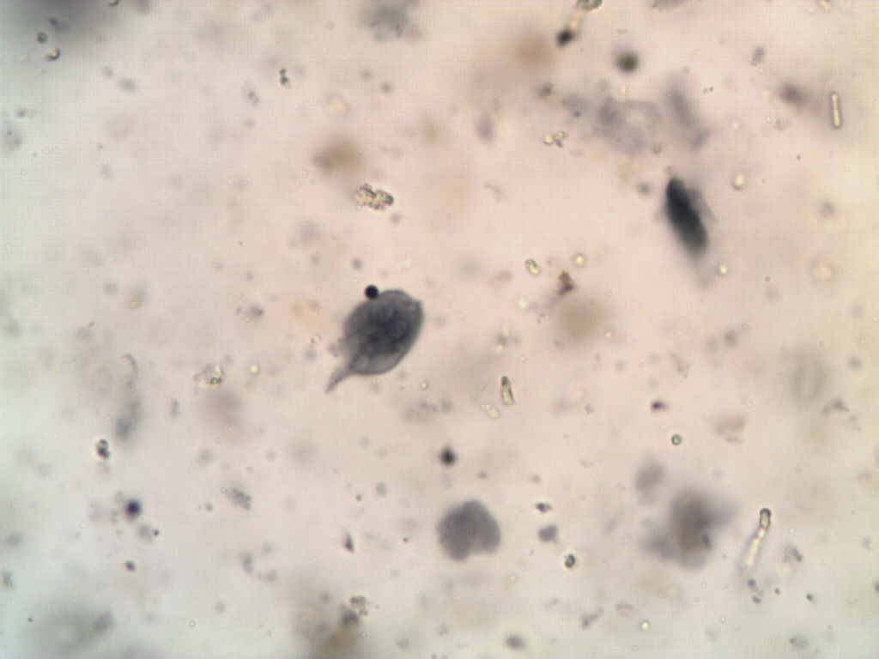Be able to recognize the example ***Giardia lamblia*.**
3. Where is this organism located in its host?

Haploid Nuclei

1. Where can this be found in California?
2. How are people infected?
3. What are the symptoms caused by this organism?

**Station 20 – Clade2: Parabasalids**

1. What are the general characteristics of the Clade Parabasalids?

Flagella

### C:\Documents and Settings\mcooper\Desktop\Bio 2 Pics\Lab 2\Trichomonas.jpgBe able to recognize the example *Trichomonas vaginalis*.

1. What does this organism cause?
2. How is this organism transmitted?

**Station 21 – Clade2: Euglenozoans**

1. What are the general characteristics of the Clade Euglenozoans?
2. What type of taxa does this clade include?
3. What are the two best known clades in Euglenozoans?

**Station 22 – Clade3: Kinetoplastids**

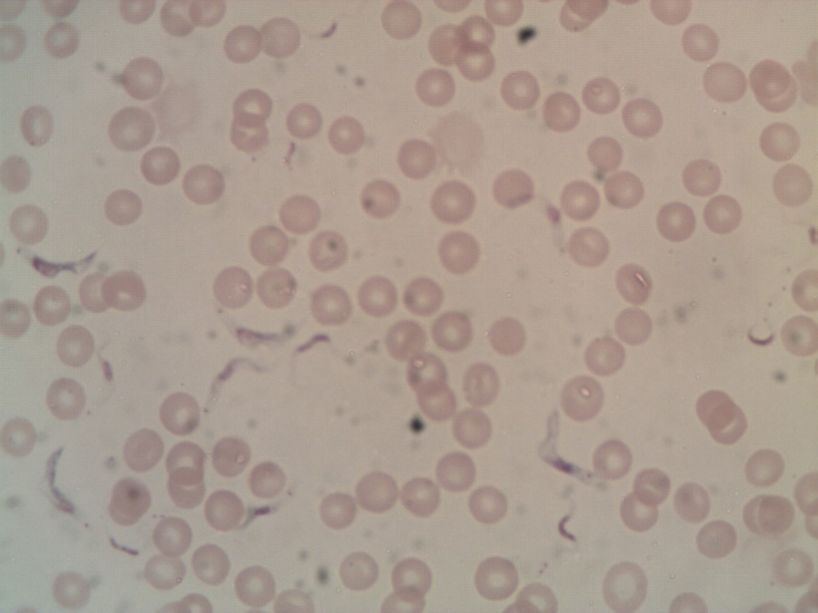

### What are the general characteristics of the clade Kinetoplastids?

RBC’s

### What different lifestyles do these organisms demonstrate?

*Trypanosoma*

### Be able to recognize the example *Trypanosoma sp.*

1. What does this organism cause in Africa? What is its vector?
2. What does this organism cause in South America? What is its vector?

**Station 23 – Clade3: Euglenids**

1. 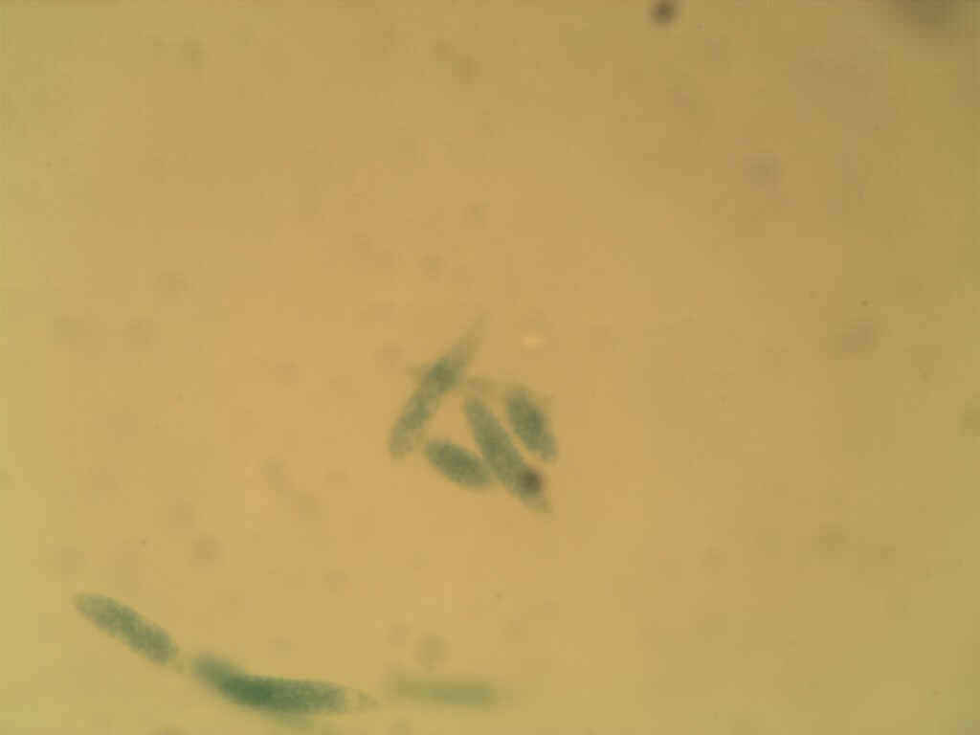What are the general characteristics of the clade Euglenids?
2. Be able to recognize the example ***Euglena sp*.**
3. Where are this organism found?

1. What is the term used when an organism is autotrophic in sunlight but when unavailable, they can become heterotrophic?

##### **C:\Users\mcooper\Desktop\Cladogram pics\SAR cladogram.pngStation 24 - Supergroup: SAR**

1. What characteristics are found in the supergroup SAR?

Alveolata Stramenopila

1. When did this supergroup evolve? What is the evidence for this?
2. What are the two clades included in this supergroup?

Rhizaria

## C:\Users\mcooper\Desktop\Clade pics\Alveolata Clade.pngStation 25 – Clade1: Alveolata

### What are the general characteristics of the clade Alveolata?

### What are the three clades included in the larger clade Alveolata?

**Station 26 – Clade2: Dinoflagellates**

1. What are the general characteristics of the clade Dinoflagellates?
2. Where are dinoflagellates found?
3. Be able to recognize the example as a **Dinoflagellate.**

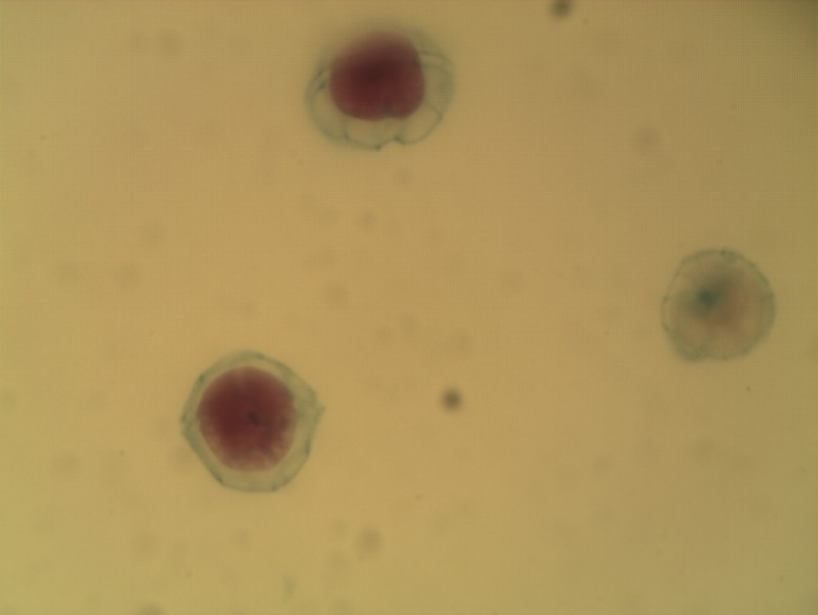

1. What does this organism cause?
2. What does this organism release and what does it cause?
3. How do they feed?

Groove for flagella

**Station 27 – Clade2: Apicomplexans**

1. What are the general characteristics of the clade Apicomplexans?
2. Where are the pathenogenic species found?

RBC’s

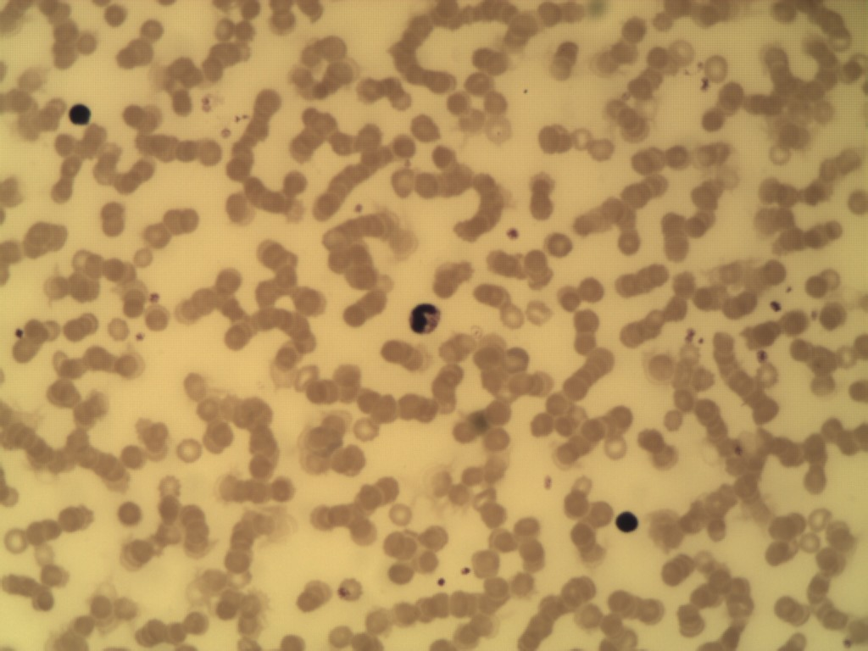

1. Be able to recognize the example ***Plasmodium* sp.**
2. What does this organism cause?
3. How is this organism transmitted?

***Plasmodium***

1. What parts of the human does this organism attack?

**Station 28 - Clade2: Ciliates**

1. What are the general characteristics of the clade Ciliates?
2. Where are ciliates found?
3. What lifestyles do these taxa demonstrate?
4. Be able to recognize the examples ***Spirostomum and Vorticella.***

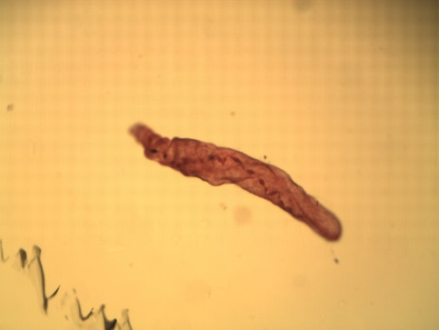

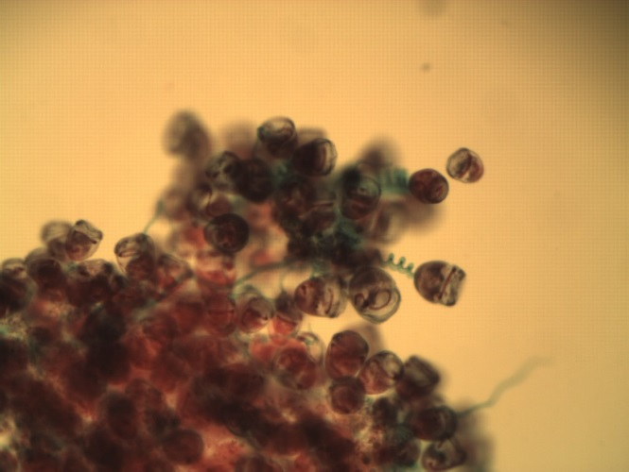

1. Use the example *Paramecium* to demonstrate how Ciliates can reproduce.
2. What is the name of the process where they exchange nuclei standing side by side? Which nuclei or exchanged? Is it sexual or asexual?

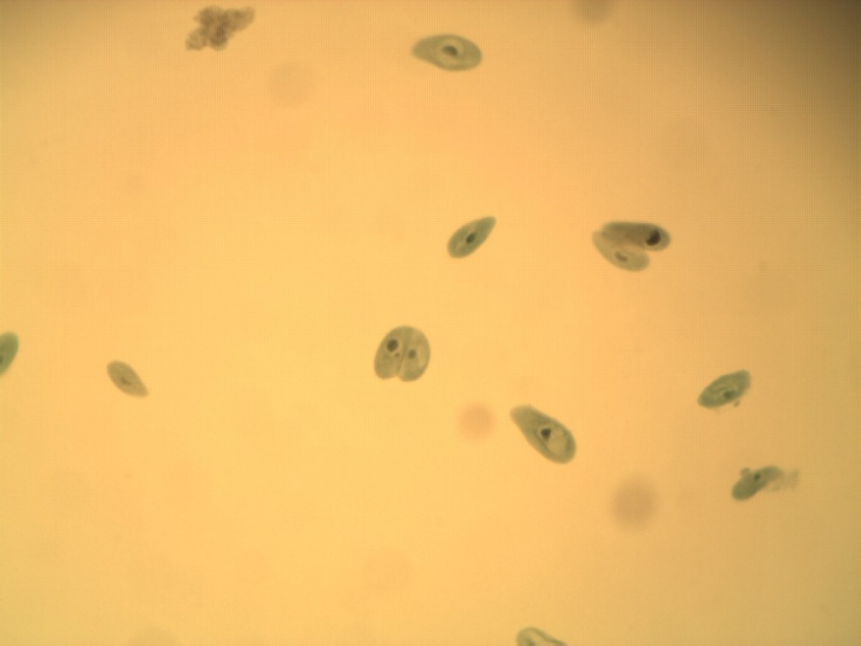

1. What is the name of the process where they appear to reproduce end to end? Is it sexual or asexual?

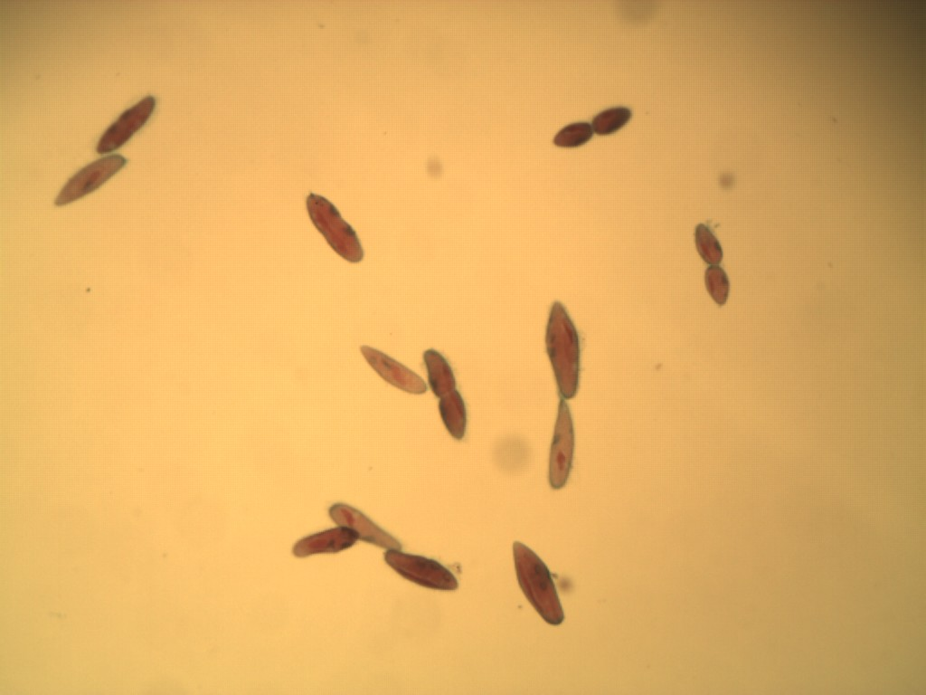

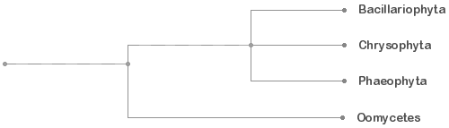**Station 29 – Clade1: Stramenopila**

### What are the general characteristics of the clade Stramenopila?

### What are the four clades included in the larger clade Stramenopila?

# 

# Station 30 – Clade2: Bacillariophyta

### What are the general characteristics of the clade Bacillariophyta?

### Where are diatoms found?

### Be able to recognize the example Diatoms.

* 1. 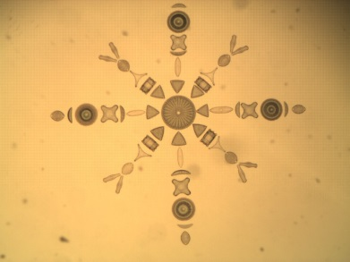What are fossilized diatoms known as?
  2. What are they used for?
  3. How do they help reducing global climate change?

**Station 31 – Clade2: Chrysophyta**

1. What are the general characteristics of the clade Chrysophyta?

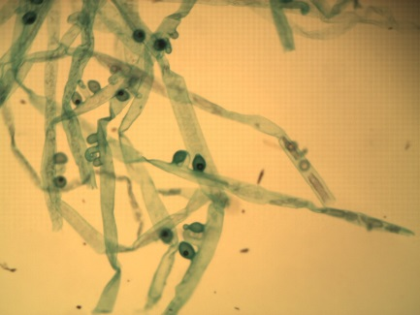

1. Where is Golden Algae found?
2. How do they feed?
3. What do they do to survive harsh conditions?

**Station 32 – Clade2: Phaeophyta**

# What are the general characteristics for the clade Phaeophyta?

# Where are they found?

# 

# How is algin used?

# Be able to recognize the examples of Brown Algae in the jars (*Fucus, Laminaria, Sargassum*)

# Examine the specimen of *Fucus* in the fingerbowl.

1. What is the name of a plant-like structure that lacks true roots, stems and leaves?
2. Be able to identify the following external structures: **holdfast, stipe, blades, airbladders, receptacles, and ostioles (openings).**
3. Observe both the male and female **conceptacles**. In the male, find the branched **antheridia** and the **sperm**. Surrounding the antheridia, there are sterile hairs called **paraphyses**, which are used for protection. In the female, observe the **oogonia** and their **eggs** along with the **paraphyses**.
4. The Brown Algae “plant” looking specimen in the fingerbowl belongs to which generation? (haploid (n) or diploid (2n))

Oogonium w/ eggs

Ostioles

Antheridium (w/ sperm)

**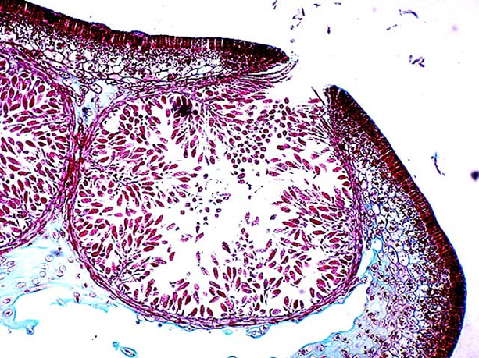**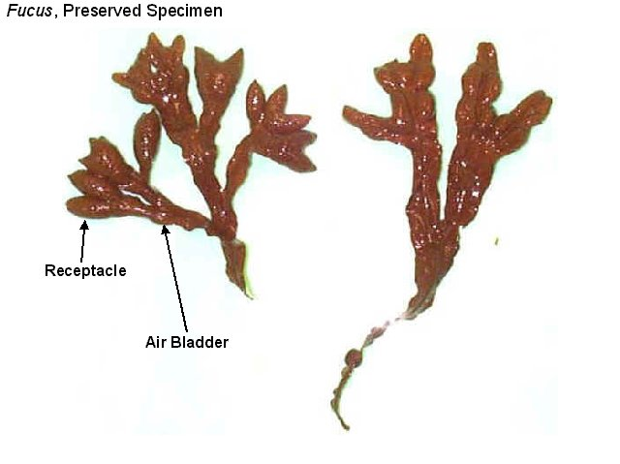**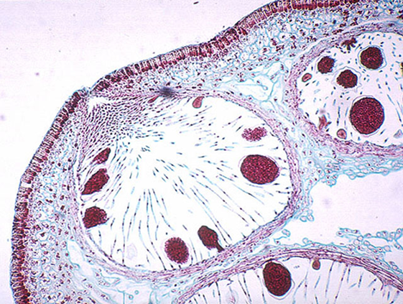**

Stipe

Paraphyses

Conceptacle

Conceptacle

Holdfast

**Station 33 – Clade2: Oomycetes**

### What are the general characteristics for the clade Oomycetes?

### What organisms are included in this clade?

### What lifestyle do these organisms demonstrate and why?

### What two major agriculture problems has it caused?

***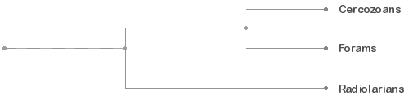***

##### **Station 34 – Clade1: Rhizaria**

1. What characteristics are found in the supergroup Rhizaria?
2. What are the three clades included in this clade?
3. Where are they found?

**Station 35 – Clade2: Cercozoans**

### What are the general characteristics for the clade Cercozoans?

### What lifestyle do these organisms demonstrate?

### What have they evolved? How is this different from plastids?

**Station 36– Clade2: Foraminiferans**

1. What are general characteristics for the clade Foraminiferans?

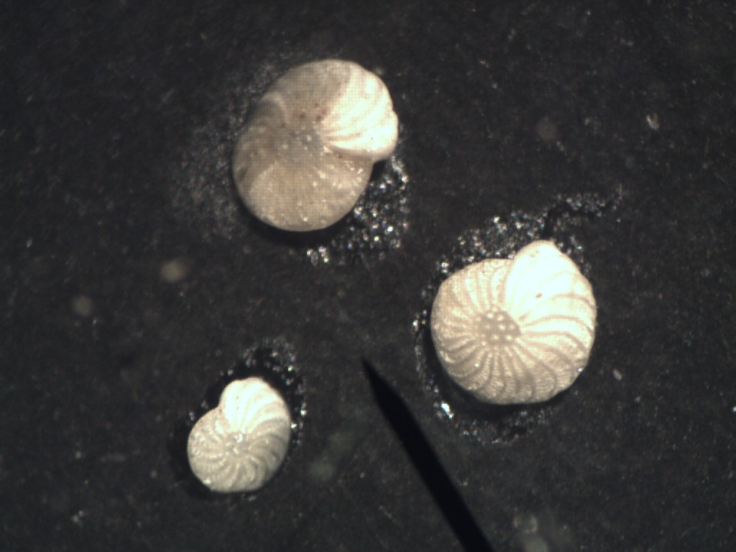

1. Know the example of **Foraminiferans.**
2. Where do these organisms live?
3. What do they make up?
4. What are their tests made of? What are they symbiotic with and what do they provide them?

**Station 37 – Clade2: Radiolarians**

### What are the general characteristics for the clade: Radiolarians?

1. Know the example **Radiolarian**s.

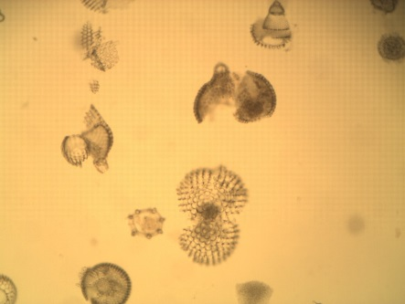

1. Where do these organisms live?
2. What are their tests made of?
3. What do they form after they die?

##### **Protista (cont.)**

##### **C:\Users\mcooper\Desktop\Clade pics\Archaeoplastida Clade.pngStation 1 - Supergroup: Archaeplastida**

1. What characteristics are found in the supergroup Archaeplastida?
2. When did this supergroup evolve?
3. Where are the three clades included in this supergroup?

**Station 2 – Clade2: Rhodophyta**

### What are the general characteristics for the clade Rhodophyta?

### Know the example Red algae: *Corallina* and *Chondrus*.

1. Where do these organisms live?
2. How are they used?
3. The red algae “plant” looking specimen in the fingerbowl belongs to which generation? (haploid (n), diploid (2n) and/or tetraploid (4n) )

**Station 3 – Clade2: Chlorophyta**

### What are the general characteristics for the clade Chlorophyta?

1. What is the name of the kingdom some cladists what to combine Chlorophyta and Higher Plants in?
2. Where are these organisms found?
3. What two groups are commonly called “Green Algae”?
4. **Know the following example Chlorophytes: *Chara, Acetabularia, Ulva, Cladophora***

# Station 4 – Clade2: Chlorophyta Examples

|  |  |  |  |  |
| --- | --- | --- | --- | --- |
|  | Cellular  Organization | Unique Characters to identify | Habitat | Example  Nucleus at Isthmus |
| *Desmids* |  | **Nucleus, isthmus, and chloroplasts**. | Chloroplast |  |
| *Volvox* |  | **Vegetative cells, protoplasmic strands, and daughter colonies** | Vegetative Cell  Daughter Colony | http://etc.usf.edu/clipart/5900/5905/volvox_1_lg.gif |
| *Protococcus* |  | **None**  What are they often confused with? |  |  |
| *Spirogyra* |  | **Chloroplasts, conjugation tube, male gamete, female gamete, and Zygospores**.  What are the gametes in the species referred to as? Why? | Male Gamete  Zygospore  Female Gamete  Chloroplast  Conjugation Tube |  |
| *Ulothrix* |  | **Chloroplasts**  What structure demonstrates specialization?  Are the filaments haploid or diploid? |  | Chloroplast |

**Station 5 – Clade2: Charophytes**

1. What are the general characteristics for the clade Charophytes?
2. Where are they found?
3. What two groups are commonly called “Green Algae”?
4. What are the four distinctive traits they have share with higher plants?

**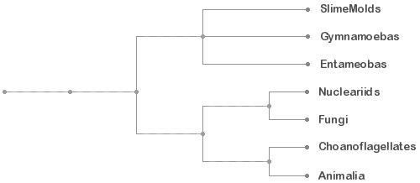Station 6 – Supergroup: Unikonta**

1. What characteristics are found in the supergroup Unikonta?

Amoebozoans Opisthokonts

1. Where does evidence suggest they evolved from?
2. Where are the two main clades included in this supergroup?

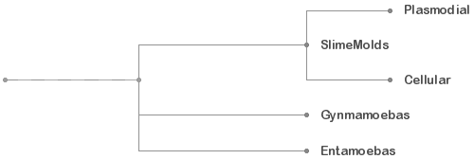

**Station 7 – Clade1: Amoebozoans**

### What are the general characteristics of the clade Amoebozoans?

### What are the three clades included in the larger clade Amoebozoans?

**Station 8 – Clade2: Slime Molds**

### What are the general characteristics of the Slime Molds?

1. What do they feed on?
2. Where are they found?
3. What two clades are they divided into? Why?

**Station 9 – Clade3: Plasmodial Slime Molds**

1. What are the general characteristics of Plasmodial Slime Molds?
2. Where are they found?
3. Why do the form a plasmodium?

**Station 10 – Clade3: Cellular Slime Molds**

1. What are the general characteristics of Cellular Slime Molds?
2. Where are they found?
3. Why do the form a plasmodium?

**Station 11 – Clade2: Gymnamoebas**

1. What are the general characteristics of Gymnamoebas?

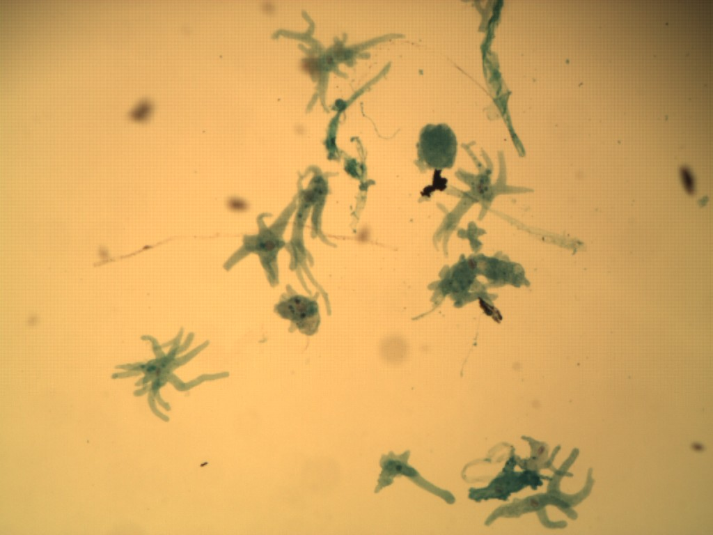

1. Where do these organisms live?
2. How do they feed?

**Station 12 – Clade2: Entameobas**

1. What are the general characteristics of Entamoebas?
2. What species do Entamoebas infect?

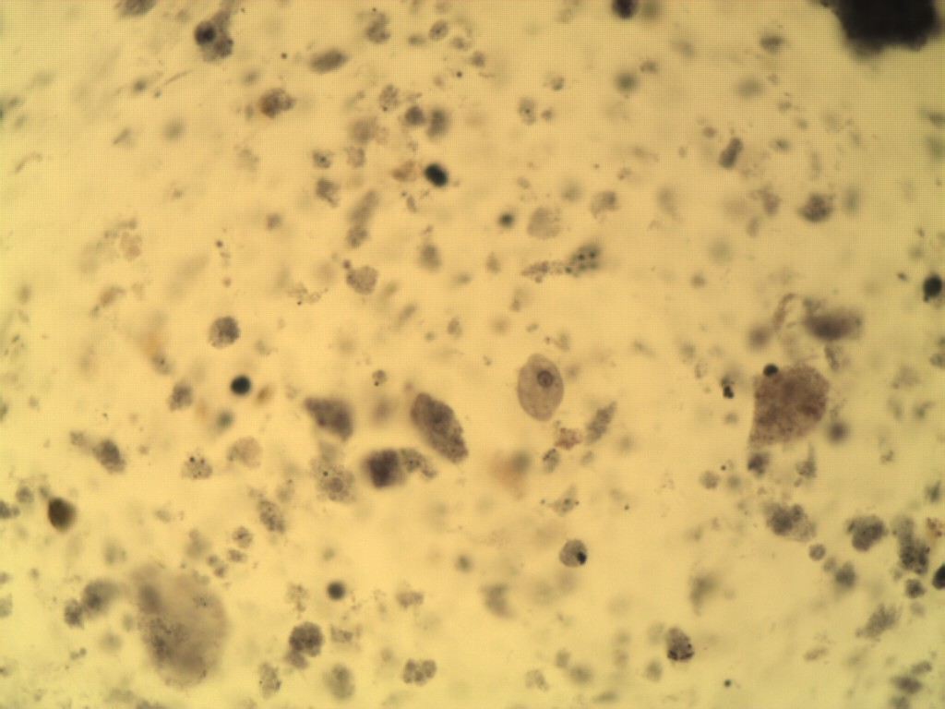

1. How many species are found in humans?
2. Which is the only one that is pathogenic in humans?
3. What are the symptoms caused by this species and how many deaths occur worldwide each year?

**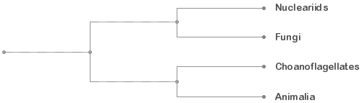Station 13 – Clade1: Opisthokonts**

### What are the general characteristics of the clade Opisthokonts?

### What are the four clades included in the larger clade Opisthokonts?

**Station 14 – Clade2: Nucleariids**

### What are the general characteristics found in the Nucleariids?

### Where are Nucleariids found?

### Why do they form pseudopods?

**Station 15 – Clade2: Choanoflagellates**

### fig_28_26

### What are the general characteristics found in the clade: Choanoflagellates?

### Where are they found?

### What does DNA suggest they are a sister group to?

**FUNGI** **CLASSIFICATION:**

**Domain: Eukarya** (**Supergroup: Opisthokonts)**

**Kingdom: Fungi**

Division: Chytrids - Chytrids

Division: Zygomycetes - Coenocytic Fungi

Division: Glomeromycetes - Arbuscular Mycorrhizae

Division: Ascomycetes - Sac Fungi & Imperfect Fungi

Division: Basidiomycetes - Club Fungi

Symbiotic relationships: Lichen

**INTRODUCTION FOR FUNGI**

Fungi are **multicellular eukaryotes**. All fungi are **heterotrophs** and acquire their nutrients by **absorption**. Foods are digested outside the organism by enzymes released by the fungi and then the nutrients are absorbed. Lacking chlorophyll, these organisms are entirely dependent upon organic matter. Most fungi derive their nutrients from dead organic compounds **(saprobes or decomposers)**, but some draw their nourishment from living plant or animal material **(parasites)**.Evolutionary history suggests they are more closely related to animals than plants but historically they have been taught in botany courses and due to time constraints for each practicum, we have included them here.

**Station 16 – Kingdom Fungi**

1. What supergroup do they belong to and what characteristic are responsible for this positioning?
2. What characteristics are specific to fungi?
3. How many species have been identified? How many species of fungi probably exist?
4. When did the show up in the fossil record? How long ago did they diverge from animals? Why the discrepancy?

**Station 17 – Division: Chytridomycota – Chytrids**

The chytrids are thought to be the most primitive type of fungi and a link between protists and fungi.

1. What are the general characteristics found in the division Chytridomycota?

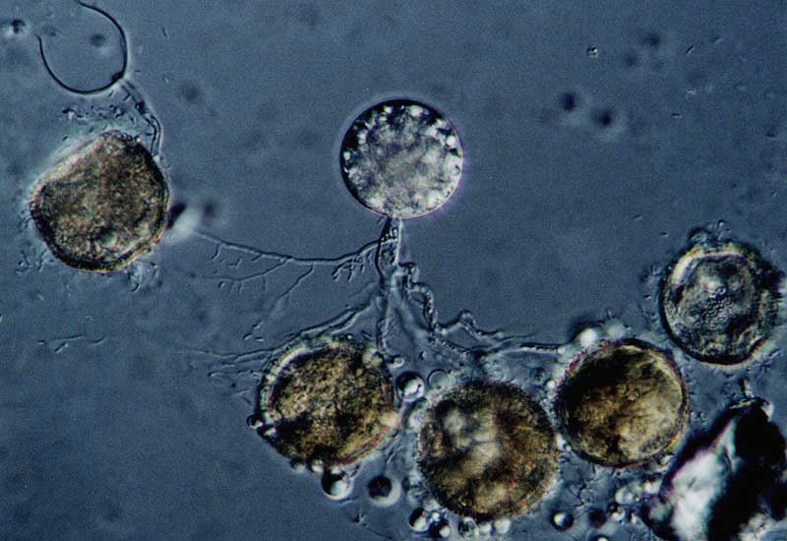

1. Where are these organisms found?
2. What do these organisms have in common with “protists”?
3. What do these organisms have in common with fungi?

**No Example Available for the Chytrids**

**Station 18 - Division: Zygomycetes**

1. What is the common name of the fungi found in this division? What are some examples?
2. What are the general characteristics found in the division Zygomycetes?
3. Where are these organisms found?
4. Example *Rhizopus* *sp.* – Black Bread Mold. Observe the petri dish or slant (under a dissecting microscope) of the living culture *Rhizopus* growing on agar. The white hairs are the **hyphae** that make up the **mycelium**. The black objects are **sporangia**, containing the asexually produced spores. Be able to distinguish *Rhizopus* from the other fungi slants or plates.

a. What are the names of the hyphae that travel horizontally along the agar?

b.. What are the name of the structures that travel downward?

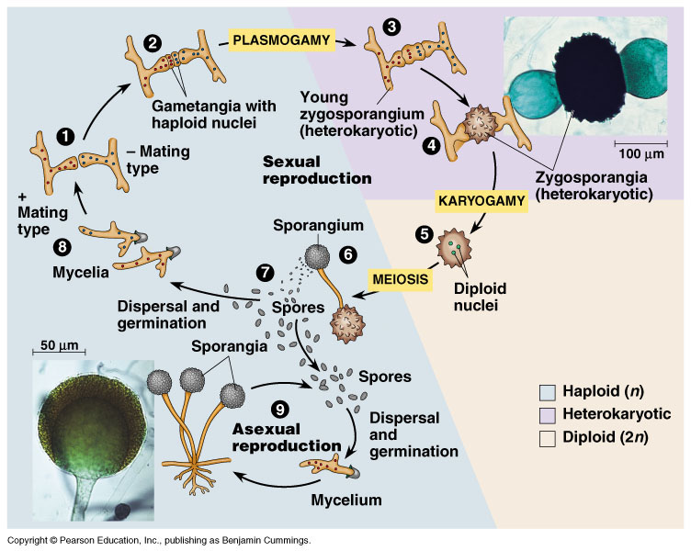

Sporangia

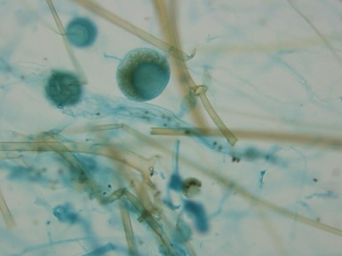**Station 19 – Asexual Reproduction of *Rhizopus***

1. What is the name of the structure these fungi use to reproduce asexually?
2. Be able to identify the following structures: **hyphae, mycelium, sporangia, sporangiophores** on the slide.

Sporangiophore

**Station 20 – Genetic Reproduction of *Rhizopus***

1. What is the name of the process for Genetic Reproduction in *Rhizopus*?

Progamete

1. What is the term used for fusion of the cytoplasm?
2. 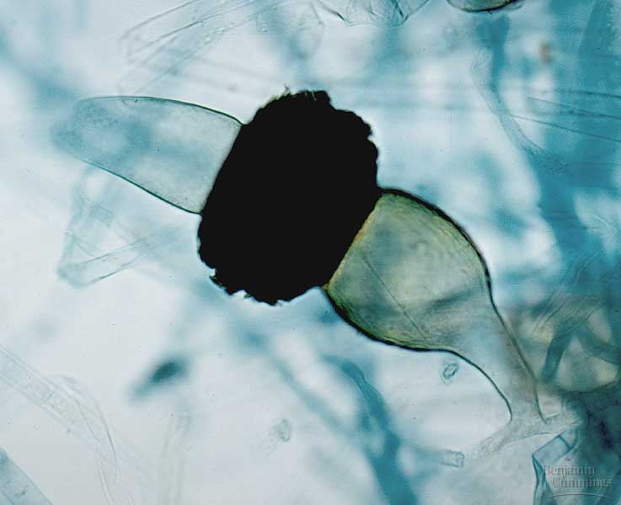What is the term used when a cell has two nuclei?
3. What is the term used when the nuclei fuse together?
4. Observe a slide of *Rhizopus* conjugating. Be able to identify the following structures: **progametes and zygospore**.

Zygospore

**Station 21 - Division: Glomeromycetes - Arbuscular Mycorrhizae**

These individuals were once thought to be part of the Zygomycetes but molecular evidence suggests that these species should be part of their own clade.

1. What are arbuscules?
2. What percentage of plant species have symbiotic relationships with these fungi?

**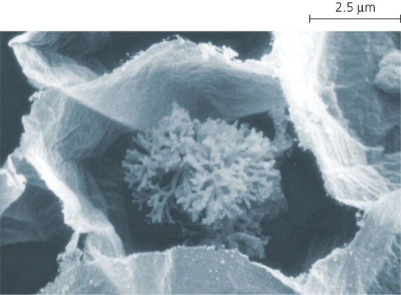**

**No Example Available for the Mycorrhizae**

**Station 22 -** **Division:** **Ascomycetes**

1. What is the common name of the fungi found in this division? What are some examples?
2. What are the general characteristics found in the division Ascomycetes?
3. Where are these organisms found?
4. What is the name of the “mushroom” in this division?
5. Be able to recognize the preserved specimens of *Peziza.*

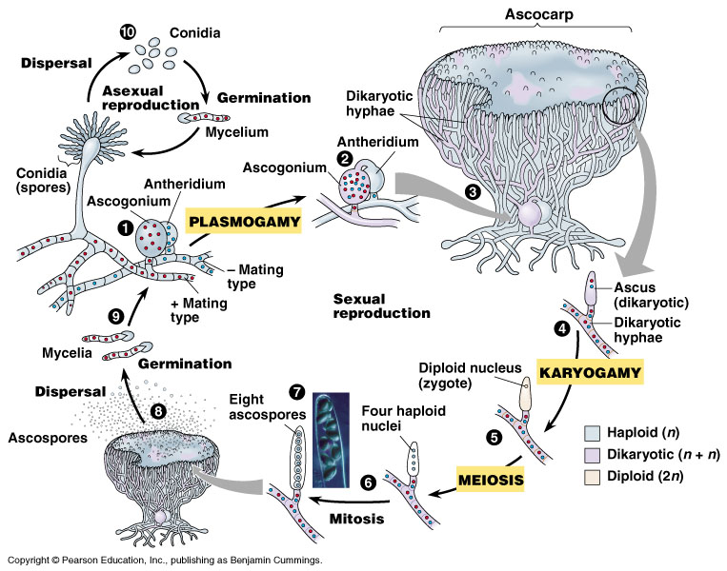

**Station 23 – Division: Ascomycetes – Sexual Reproduction**

Be able to identify the following structures of a cross section through an **ascocarp**: **hyphae, mycelium, hymenial layer, asci, and ascospores.**

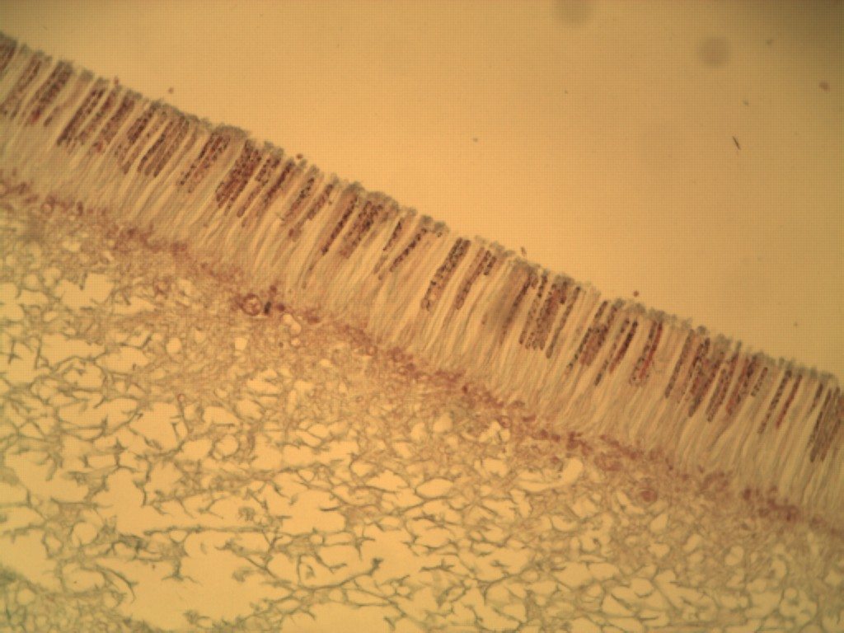

Ascospores

Asci

Hymenial Layer

Hyphae

Sexual Reproduction

**Station 24 –** **Division: Ascomycetes – Imperfect Fungi**

Examine living cultures of ***Penicillium notatum*** and ***Aspergillus niger*** in the petri dishes or slants. Note the coloring and texture of each culture. Be sure you are able to tell these apart from other cultures seen earlier.

1. What was the name of the division these species use to be placed in? Why are these fungi considered to be imperfect? Why are they now placed in the Ascomycetes?

*Penicillium notatum Aspergillus niger*

**Station 25 – Division: Ascomycetes – Imperfect Fungi**

* 1. How do Ascomycetes reproduce asexually?
  2. Be able to identify each species and the following structures: **condiophores and conidia**

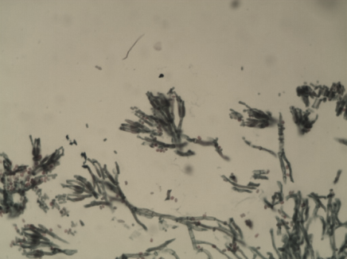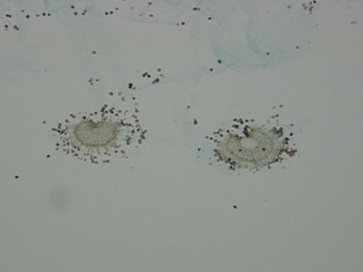

Conidia

Conidiophore

*Penicillum notatum Aspergillus niger*

**Station 26 - Division: Basidiomycetes**

1. What is the common name of the fungi found in this division? What are some examples?

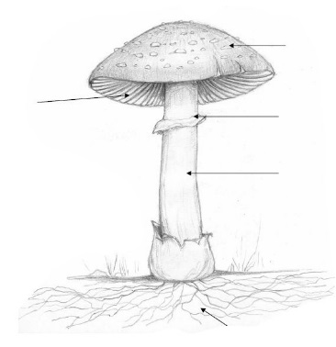

Cap

1. What are the general characteristics found in the division Basidomycetes?

Annulus

Gills

1. Where are these organisms found?

Stipe

1. What is the name of the “mushroom” in this division?
2. Be able to recognize the preserved specimens and be able to identify the following structures**: cap, annulus, gills and stipe.**

**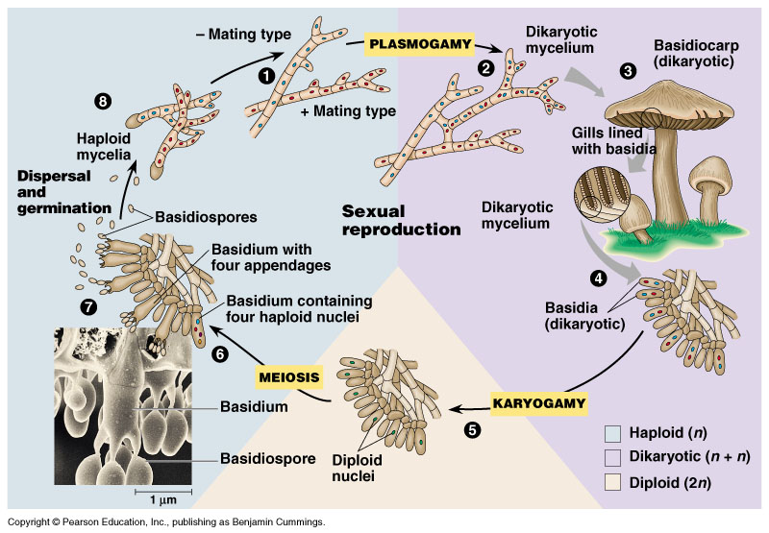**

**Station 27 – Division: Basidiomycetes – Sexual Reproduction**

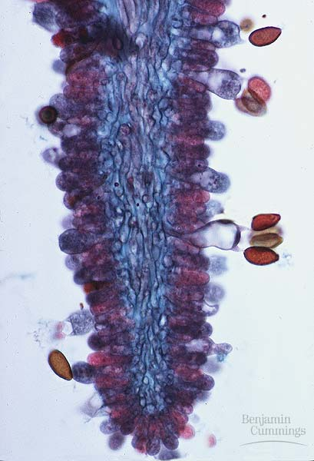 Examine a prepared slide of *Coprinus*, which shows a longitudinal cross section through a basidiocarp. Be able to identify the following structures: **hyphae, mycelium, hymenial layer, basidia, and basidiospores.**

Basidia

Basidiospores

Hymenial Layer

Gill made of Hyphae

Sexual Reproduction

**Station 28 – Division: Basidiomycetes – Bird Nest Fungi**

Be able to recognize this example.

1. How does this group get its name?
2. How do they feed?
3. Where are they found?
4. What are the “nests” used for? How far can the spores travel?

**Station 29 – Lichen**

Examine various lichens externally.

1. What two organisms make up the symbiotic relationship found in lichens?

2. What does each organism bring to the relationship?