Protist Phylogeny

**\*Clade 2**

**Sugergroup**

**Clade 1**

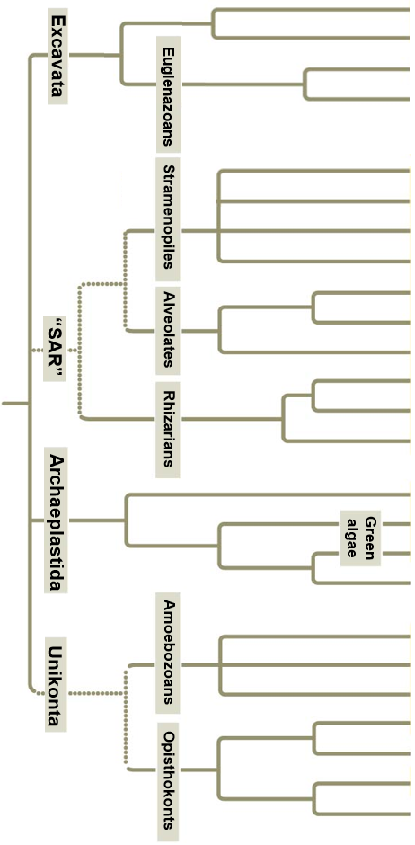

Diplomonades

Parabasalides

Gymnamoebas

Charophytes

Ciliates

Euglenids

Kintoplastids

Choanoflagellates

**Animals**

**Fungi**

Nuclearids

Entamoebas

Slime molds

**Land plants**

Chlorophytes

Red algae

Radiolarians

Cercozoans

Foramaniferans

Apicomplexans

Dinoflagellates

Brown algae

Golden algae

Diatoms

Oomycetes