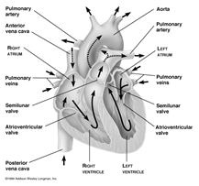

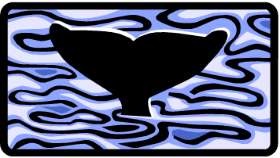

Biology 2

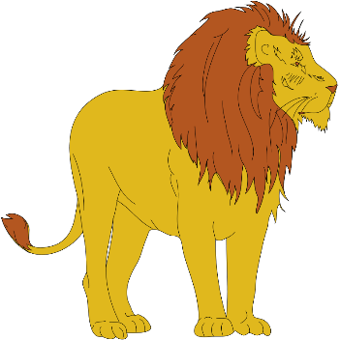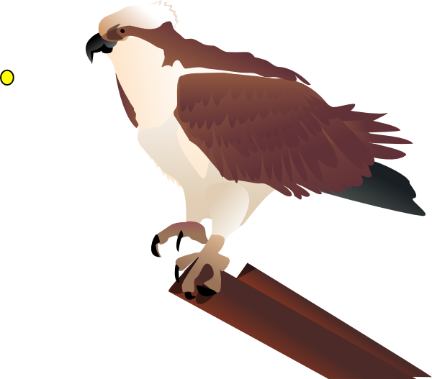Lab Packet

For

Practical 5

AN01968_

**CLASSIFICATION:**

**Domain: Eukarya Kingdom: Animalia**

**Phylum: Chordata – Chordates**

Class: Aves – Birds

Order: Struthioniformes - Ostriches Order: Galliformes - Quail

Order: Rheiformes – Rheas Order: Gruiformes – Coots

Order: Casuariiformes – Cassowaries Order: Charadriiformes – Gulls and Allies

Order: Apterygiformes – Kiwis Order: Columbiformes – Pigeons

Order: Sphenisciformes - PenguinsOrder: Psittaciformes – Parrots

Order: Gaviiformes - Loons Order: Cuculiformes – Roadrunners

Order: Podicipediformes – Grebes Order: Strigiformes - Owls

Order: Procellariiformes – Tube noses Order: Caprimulgiformes – Nighthawks

Order: Pelicaniformes – Pelicans Order: Apodiformes – Hummingbirds

Order: Ciconiiformes – Herons/Egrets Order: Trogonifomes – Trogons

Order: Phoenicopteriformes - Flamingos Order: Coraciformes – Kingfishers

Order: Anseriformes – Ducks Order: Piciformes – Woodpeckers

Order: Falconiformes – Raptors Order: Passeriformes - Songbirds

**Introduction – Birds**

Although chordates vary widely in appearance, they are distinguished as a phylum by the presence of four anatomical features that appear sometime during their life time. They exhibit deuterostome development and bilateral symmetry. Chordates only comprise 5% of the animal species but may be the most commonly known phylum. Birds are endothermic homeotherms which have adapted to many different ecosystems in the world.

**Station 1 – Class: Aves**

1. What three adaptations do birds have for flight?
2. What do all species of birds have?
3. What dinosaurs did birds emerge within? When did they show up?
4. Where are birds found?

**Station 2 – Evolutionary History - *Archaeopteryx***

1. What characteristics are seen in *Archaeopteryx* that are bird-like?
2. What characteristics are seen in *Archaeopteryx* that are reptile-like?

**Station 3 – General Characteristics - Feathers**

1. What are feathers made of?
2. Be able to recognize the six types of feathers and know their functions. Also be able to recognize the feathers in the display.

**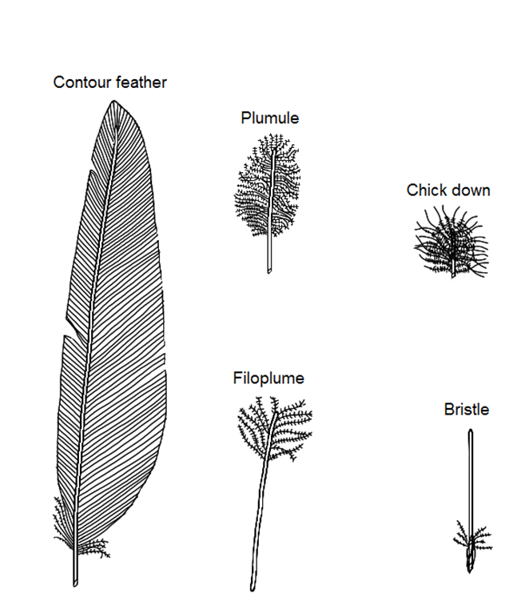**

**Station 4 – General Characteristics - Color**

* 1. What causes the different colors we see in bird’s today?
  2. What are the different types of plumage mentioned and what is their function?
  3. Know what produces the following colors in the following birds.

Red in Northern Cardinals:

Pink in Flamingo’s:

Blue in Western Scrub-Jays

Yellow in the American Goldfinch

Iridescent colors in the Anna’s Hummingbird

**Station 5 – General Characteristics - Bones and Muscles**

1. What are the three regions in birds where bones are fused together and what are each of them called?
2. What is the muscle in birds which lifts their wings? What is the muscle that is used to lower the wings?
3. How much of a bird’s body mass is accounted for by the flight muscles?
4. Do birds have teeth? Why or why not?

**Station 6 – General Characteristics – Bipedalism and Feet**

1. Although most tetrapods are quadrupeds, what is the term used for birds?
2. The part of a bird’s leg that looks like a “backwards” knee is actually what part?
3. What is the name of the type of foot seen on the left below?
4. What is the name of the type of foot seen on the right?

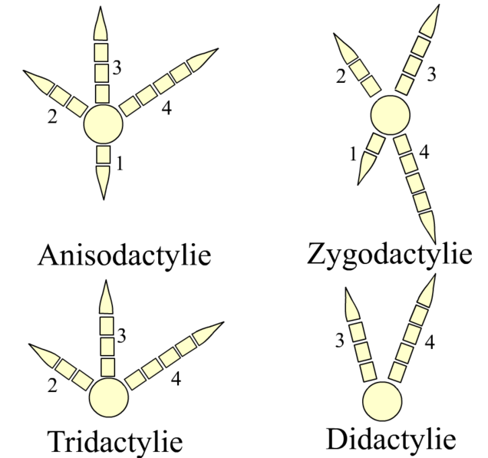

**Station 7 – General Characteristics – Metabolism**

1. What type of metabolic rate do birds have?
2. What is the normal range of body temperatures?
3. What zones are birds usually larger? Why?
4. What two functions does the respiratory system play?
5. What respiratory structures do birds have?
6. What do air sacs permit?

**Station 8 – General Characteristics - Reproduction**

1. Other vertebrates lay eggs, but bird egg laying is unique among vertebrates. Why?
2. What is the largest egg?
3. What is the smallest egg?

**Station 9 – Reproductive Behavior – Monogamy**

1. What is meant by Socially Monogamous?
2. What are Extra-pair copulations?
3. How many species of birds are considered Socially Monogamous?

**Station 10 – Reproductive Behavior – Red-winged Blackbirds**

1. What is polygyny?
2. What conditions favor this condition?

**Station 11 – Reproductive Behavior – Sage Grouse**

1. What is Lekking? What is the name of the area used for display?
2. What are the benefits of Lekking?

**Station 12 – Reproductive Behavior – Northern Jacana**

1. What is polyandry?
2. Using this type of reproductive behavior, what happens to the sexual roles in these birds?
3. What is the evolutionary reason for polyandry?

**Station 13 – Reproductive Behavior – Acorn Woodpecker**

1. What is polygyandry?
2. Why do Acorn woodpeckers primarily live in groups?
3. What is special about the way they nest?

**Station 14 – Reproductive Behavior – Brown-headed Cowbirds**

1. What is brood parasitism?
2. How many species do they parasitize?
3. What is the cost to the host species?

**Station 15 – Reproductive Behavior – Phainopepla**

1. What is this birds typical diet?
2. What is unique about this birds nesting behavior?
3. How do they behave in the desert environment?
4. How do they behave in the woodland area?

**Station 16 – Feeding Behavior – Adaptations**

|  |  |  |
| --- | --- | --- |
| **Bird Skull** | **Adaptation** | **Other** |
| **Ostrich** |  |  |
| **Brown Kiwi** |  |  |
| **Indian Yellow-nosed Albatross** |  |  |
| **Great Blue Heron** |  |  |
| **Scarlet Ibis** |  |  |
| **Roseate Spoonbill** |  |  |
| **Caribbean Flamingo** |  |  |
| **Duck** |  |  |
| **Harpy Eagle** |  |  |
| **Peregrine Falcon** |  |  |
| **Turkey Vulture** |  |  |
| **California Condor** |  |  |
| **Common Snipe** |  |  |
| **King Penguin** |  |  |
| **Black Hornbill** |  |  |
| **Toco Toucan** |  |  |
| **Scarlet Macaw** |  |  |
| **Owl** |  |  |
| **Pileated Woodpecker** |  |  |
| **Wren** |  |  |

**Station 17 – Resource Partitioning**

1. What is resource portioning?
2. How does an American Avocet’s bill differ from a Black legged Stilt?

**Station 18 – Ducks (Dabblers vs. Divers)**

1. What is a dabbler? What is a diver?
2. How do the legs differ between these two different types of duck?
3. Know the Northern Pintail and Northern Shoveler which are dabblers and the Hooded Merganser is a diving duck.

**Station 19 – Birds of Prey - Loggerhead Shrikes**

1. Why are they considered a bird of prey?
2. How do they kill their food?
3. What is their nickname?

**Station 20 – Birds of Prey - Hawks and Falcons**

1. What is the common diet for a Red-tailed Hawk?
2. What is the Peregrine Falcon known for? What do they eat?
3. What is a Kestrel? What do they eat? What is “unique” about their flight pattern?

**Station 21 – Birds of Prey - Owls**

1. Why are owls thought to be nocturnal?
2. How far can Owl’s turn their head? Why can they do this? Why is it necessary?
3. Which species of Owl is diurnal? How do the young protect themselves in the nest?
4. Know the difference between the Barn Owl and the Great Horned Owl.

**Station 22 – Avoiding Predators- Killdeer**

1. Where do these birds lay their eggs?
2. How do the adults protect their young?

**Station 23 – Introduced Species**

1. Why were Starling introduced to the United States? What problems are they causing?
2. What is one of the more common introduced species in our area? What was their original name?

**Station 24 – Communication**

1. How do birds communicate?
2. What do songs consist of? How does a song of a cardinal differ from that of a mockingbird?
3. How do birds produce these sounds? Why do mourning doves making only cooing noises?
4. What is a call? How do bushtits use these?
5. How do you recognize the call of a Wrentit?
6. What separates the Western Meadowlark species from the Eastern Meadowlark?

**Station 25 – Bird Songs**

Be able to recognize the songs from the following birds.

1. Barn Owl

1. Great Horned Owl
2. California Quail
3. Red-Shouldered Hawk
4. Red-Tailed Hawk
5. Cactus Wren
6. Bushtit
7. Wren Tit
8. Mocking Bird
9. Mourning Dove
10. Acorn Woodpecker
11. Belted Kingfisher
12. Killdeer
13. American Kestrel
14. Red-winged Blackbird

**Station 26- Bird Migration**

1. What are the four groups birds can be placed in?
2. Why do birds migrate?
3. What are the four “flyways” in North America?

**Station 27 – Desert Adaptations – Roadrunners**

1. What is torpor? Why do roadrunners do this?
2. What adaptation do Roadrunners have to help them use less energy “waking up” from torpor?

**Station 28 – Desert Adaptations - Cactus Wrens**

1. How did these birds get their name?
2. Why do these birds make multiple nests?

**Station 29 – Desert Adaptations – Gambel’s Quail**

1. What is their typical body temperature? What can they do to this temperature to reduce water loss?
2. How much body weight can they lose in water?

**Station 30 – Other Behaviors – Penguins and Alcids**

1. Where are penguins found? Where are Murrelets and Auklets found?
2. What do they have in common? How are they different?

**Station 31 – Other Behaviors - Hummingbirds and Swallows**

1. What does the order these birds are in mean?
2. What do hummingbirds eat?
3. Be able to identify the hummingbirds at this station.
4. What do swallows eat?
5. What types of nest do they make?
6. Be able to identify the swallows at this station

**Station 32 – Other Behaviors – Common Birds**

Be able to recognize the following birds in your neighborhoods

|  |  |  |  |
| --- | --- | --- | --- |
| **Bird** | **Location** | **Food** | **Other** |
| American Robin |  |  |  |
| Brewer’s Blackbird |  |  |  |
| Black Phoebe |  |  |  |
| California Gnatcatcher |  |  |  |
| California Thrasher |  |  |  |
| California Towhee |  |  |  |
| Crow |  |  |  |
| House Finch |  |  |  |
| Northern Oriole |  |  |  |
| Plain Titmouse |  |  |  |
| Spotted Towhee |  |  |  |
| Western Bluebird |  |  |  |
| Western Kingbird |  |  |  |
| Yellow-rumped Warbler |  |  |  |

**Station 33– Bird Orders**

Be able to identify the examples of each of the bird orders.

|  |  |  |
| --- | --- | --- |
| **Order** | **Description** | **Characteristics** |
| Order: Pelicaniformes | Pelicans – Four webbed toes, long beak with throat pouch |  |
| Order: Coraciformes | Kingfishers – Strong prominent bill, colorful feathers |  |
| Order: Apodiformes | Hummingbirds – Small birds with short legs, small feet, with long, slender beaks |  |
| Order: Columbiformes | Pigeons, Doves – Slender bill with soft skin at base, short neck |  |
| Order: Falconiformes | Raptors – Birds of Prey |  |
| Order: Anseriformes | Ducks – Broadened bills, short legs with webbed feet |  |
| Order: Galliformes | Quail – Hen-like birds with short beaks |  |
| Order: Gruiformes | Coots – Smaller birds with short beaks |  |
| Order: Charadriiformes | Shorebirds |  |
| Order: Psittaciformes | Narrow hooked beak with brilliant plumage |  |
| Order: Cuculiformes | Greater Roadrunner – Varied, local bird with long legs and tail |  |
| Order: Strigiformes | Owls - Nocturnal birds of Prey |  |
| Order: Piciformes | Woodpeckers – Thick bill for drilling holes |  |
| Order: Casuariiformes | Cassowaries - Flightless Walking Bird (3 toes) |  |
| Order: Struthioniformes | Ostriches - Flightless Walking Bird (2 toes) |  |
| Order: Rheiformes | Rheas - Flightless Walking Bird (3 toes) |  |
| Order: Apterygiformes | Kiwis - Small flightless bird |  |
| Order: Tinamiformes | Tinamous - Poor flying birds |  |
| Order: Sphenisciformes | Penguins – Web footed, short winged, marine birds |  |
| Order: Troganiformes | Trogons – Brightly colored, long tailed tropical birds |  |
| Order: Gaviiformes | Loons – Heavy bodied, diving birds |  |
| Order: Podicipediformes | Grebes – Short legged divers with lobed feet |  |
| Order: Procellariiformes | Tubenoses – Marine birds with tubular nostrils on beack |  |
| Order: Ciconiiformes | Waders – Long-necked, long legged waders |  |
| Order: Caprimulgiformes | Nighthawks – Night fliers |  |
| Order: Passeriformes | Songbirds – very variable |  |

**Station 34 - CLASS: AVES – INTERNAL FEATURES (P 206, Figs. 8.42 – 8.43)**

|  |  |  |
| --- | --- | --- |
| **System** | **Structure** | **Function** |
| **Digestive System** | **Esophagus**  **Crop**  **Proventriculus**  **Gizzard**  **Intestine**  **Liver**  **Pancreas**  **Cloaca** |  |
| **Excretory System** | **Kidneys** |  |
| **Circulatory System** | **Atria (2)**  **Ventricle (2)**  Double Circuit system (whole system)  Compare to Mammal (Why the difference is size?) |  |
| **Respiratory System** | **Lungs**  **Air Sacs** |  |
| **Reproductive System** | Ovaries or Testes |  |

**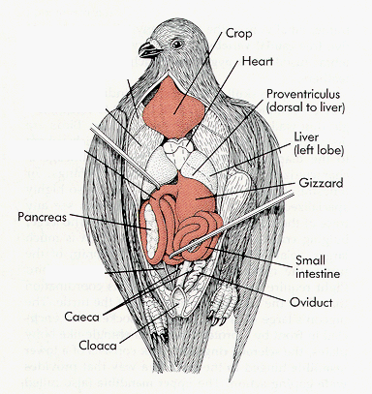**

**Station 35 – VERTEBRATE HEART SERIES**

Be able to recognize the listed structures.

1. Fish Heart (sinus venosus, atrium, ventricle, bulbus arteriosus, truncus arteriosus)
2. Amphibian Heart (sinus venosus, right atrium, left atrium, ventricle, conus arteriosus, truncus arteriosus, pulmo-cutaneous artery, aorta)
3. Turtle Heart (sinus venosus, right and left superior vena cavas, inferior vena cavas, right atrium, left atrium, ventricle, pulmonary veins, aorta)
4. Crocodile Heart (right and left superior vena cavas, inferior vena cava, right atrium, left atrium, right ventricle, left ventricle, pulmonary veins, aorta)
5. Bird Heart (right and left superior vena cavas, inferior vena cava, right atrium, left atrium, right ventricle, pulmonary arteries, aorta)
6. Mammal Heart (superior vena cava, inferior vena cava, right atrium, left atrium, right ventricle, left ventricle, pulmonary arteries, aorta)

**Station 36 – VERTEBRATE BRAIN SERIES**

Be able to recognize the listed structures and their functions

|  |  |
| --- | --- |
| Name | Function |
| Medulla Oblongata |  |
| Pons |  |
| Mesencephalon (midbrain) |  |
| Cerebellum |  |
| Optic Lobe |  |
| Olfactory Lobe |  |
| Cerebrum |  |

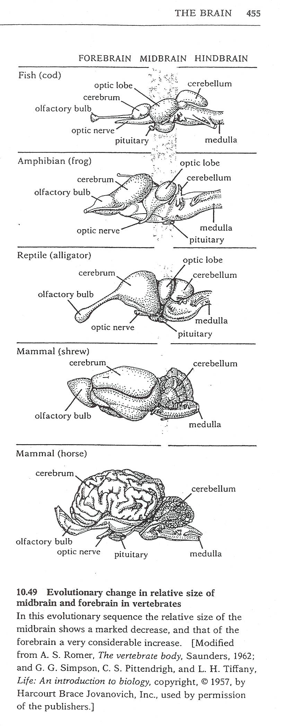

**Introduction – Mammals**

Like all chordates, mammals have the presence of four anatomical features both as juveniles and adults although in adults they are highly modified. They exhibit deuterostome development and bilateral symmetry. Mammals are endothermic, homeotherms which have adapted to survive in many different ecosystems in the world. They have hair and mammary glands to feed their young which make them unique among the animals in this kingdom.

Class: Mammalia – Mammals

Subclass: Protheria

Order: Monotremata – Monotremes

Duck-billed Platypus

Echidna

Subclass: Metatheria

Order: Marsupialia: Marsupials

Kangaroo

Koala

Bush-tailed Possum

Virginia Opossum

Subclass: Eutheria

Order: Tubulidentata – Aardvarks

Order: Proboscidea – Elephants

Order: Hyracoidea: Hyraxes

Order: Sirenia – Manatees

Order: Xenarthra – Anteaters, Sloths, Armadillos

Order: Rodentia – Rodents

Naked Mole Rats

Beaver

Ground Squirrel

Gray Squirrel

Kangaroo Rat

Capybara

Gopher

Deer Mouse

Norway Rat

Antelope Ground Squirrel

Chipmunk

Woodchuck

Order: Lagomorpha – Rabbits

Black-tailed Jackrabbit

Desert Cottontail

Pika

Order: Dermoptera – Flying Lemurs

Order: Scandentia – Tree Shrews

Order: Primates – Primates

Old World Monkeys

Olive Baboon

New World Monkeys

Great Apes

Gorilla

Orangutan

African Chimp

Bonobos

*Australopithicus afarenis*

*Australopithicus africanus*

*Parathropus bosei*

*Homo erectus*

*Homo neanderthalensis*  *Homo sapiens*

Order: Carnivora – Carnivores

Feline Family

Mountain Lion

Bobcat

African Lion

Bengal Tiger

Leopard

Jaguar

Cheetah

Canid Family

Coyote

Gray Wolf

Silver Fox

Red Fox

Gray Fox

Arctic Fox

Bear Family

Polar Bear

Alaskan Brown Bear

Grizzly Bear

American Black Bear

European Brown Bear

Giant Panda

Raccoon Family

Raccoon

Coati

Red Panda

Ringtail

Weasel Family

Long-tailed Weasel

Pine Martin

Mink

Wolverine

Badger

Skunks

River Otter

Sea Otter

Mongoose Family

Meerkats

Hyena Family

Hyenas

Pinneped Family

Walrus

California Sea Lion

Weddel Seal

Crabeater Seal

Leopard Seal

Harbor Seal

Order: Perissodactyla -Odd toed Ungulates

Equine Family

Horses

Zebra

Tapir Family

Tapirs

Rhinoceros Family

White Rhino

Black Rhino

Order: Cetartiodactyla - Even-toed Ungulates

Pig family

Warthog

Wild Boar

Peccary family

Peccary

Hippopotamus family

Hippopotamus

Camel Family

Camel

Llamas

Alpaca

Deer Family

Sika Deer

Fallow Deer

Chital (Axis) Deer

Rusa Deer

Red Deer

Elk

White-tailed Deer

Mule Deer

Moose

Caribou

Giraffe Family

Giraffe

Okapi

Bovidae Family - Pronghorn

Pronghorn

Bovidae Family - Cattle

American Bison

Water Buffalo

Banteng

Dwarf Buffalo

Asiatic Buffalo

Cape Buffalo

Bovidae Family – Small Antelope

Harvey’s Red Duiker

Bovidae Family – Spiral-horned Antelope

Chobe Bushbuck

Bovidae Family – Grazing Antelope

(OpenWoods)

Impala

Blsebok

Wildebeest

Hartebeest

Bovidae Family – Grazing Antelope (Wetlands)

Western Kob

Reedbuck

Waterbuck

Lechwe

Bovidae Family – Grazing Antelope (Horse-like)

Kalahari Gemsbok

Fringe-eared Oryx

Southern Roan

Sable Antelope

Bovidae Family – Gazelles

Springbok

Southern Grant’s Gazelle

Southern Gerenuk

Bovidae Family – Dwarf Antelopes

Kirk’s Dik-Dik

Bovidae Family – Goat Antelope

Musk Ox

Mountain Goat

Big Horn Sheep

Chamois

Himalayan Tahr

Spanish Ibex

European Mouflan

Whales Family

Pygmy Sperm Whale

Minke Whale

Blue Whale

Sperm Whale

Beluga Whale

Bottle-nosed Dolphin

White-sided Dolphin

Humpback Whale

Orca Killer Whale

Order: Chiroptera – Bats

Vampire Bat

Pallid Bat

Western Pipistrelle

Order: Insectivora – Insect Eaters

Mole

Shrew

Order: Pholiodata – Scaly Anteaters

Eland

Kudu

**Station 1 – Class: Mammalia**

1. What are the general characteristics listed for mammals?
2. When did the first mammals appear?
3. When did the modern mammalian orders appear?
4. Where are they found?

**Station 2 – General Characteristics – Hair**

1. What is it composed of?
2. What is a complete coat of fur called?
3. What are the two main layers of hair and what are they used for?
4. What are the functions of hair?

**Station 3 – General Characteristics – Middle Ear**

1. What are the names of the three ossicles?
2. What is the single bone in reptiles called? Where did the extra two middle ear bones come from?
3. What is the function of these new bones?

**Station 4 – General Characteristics – Jaw Joint and Teeth**

1. What two bones form the jaw?
2. What two bones form the jaw joint?
3. How long did it take for the synapsid skull to evolve?
4. How have vertebrate teeth changed? What are the different types and their functions?
5. What has the shift in the jaw joint allowed?

**Station 5 – General Characteristics – Mammary Glands**

1. What type of gland is a mammary gland? What is its function?
2. What type of gland is it modified from?

**Station 6 – General Characteristics – Neocortex**

1. What does the word mean? Where is it located?
2. How does the neocortex consist of? How does this area differ from rodents to larger mammals?
3. What is the name of the grooves and wrinkles? What do they allow for?
4. What are the functions of this region?

**Station 7 - Mammal Classification**

1. What are the three major types of mammals and their characteristics?

**Station 8 – Subclass: Protheria**

1. What does the word Protheria mean?
2. What therapsid ancestor characteristics do they contain?
3. When did they split from the other mammals?
4. Where were they probably found?

**Station 9 – Order: Monotremata – Be Able to recognize the two animals from this station**

1. What does the word monotremata mean?
2. What makes them different than other mammals?
3. How is milk delivery different than other mammals?
4. What do they use to locate prey?
5. Where are they found today?
6. Monotremes are one of two groups of venomous mammals. What structure delivers the venom in male Duck-billed Platypus? What behavior do they do while hunting to take advantage of their electroreceptors? Where are they found?
7. What do echidnas feed on? How do their electrosensors compare to the platypus?

**Station 10 – Subclass Metatheria**

1. What does the word Metatheria mean?
2. What do these animals give birth to? What must they attach to?
3. When did they diverge from the ancestors of placentals?
4. Where are they found today?

**Station 11 – Order: Marsupialia**

1. What makes marsupials different from placental mammals?
2. What is unique about their penis and vagina?
3. When and where did they first evolve? When did they reach Australia?
4. Be able to recognize the following animals.
   1. Kangaroo (Skull)
   2. Koala (Picture)
   3. Virginia Opossum (Skull and Specimen)
   4. Brush-tailed Possum (Meek)
5. What is unique about the Red Kangaroo?
6. What do koalas eat and what does this cause them to do?
7. What is the only marsupial found in this area (Southern California)? What type of tail do they have? What do they have on their back feet which are similar to those in primates?
8. How many teeth do opossums have? What do they eat?

1. What do they do when confronted by a predator?
2. Their immune system is robust. Why are they not carriers of rabies?
3. How are the Brush-tailed Possum different from other opossums? Where are they from and where are they found now?

**Station 12 – Subclass: Eutheria**

1. What does the word Eutheria mean?
2. How do they differ from non-eutherian mammals? What does this allow them to do?
3. When did they evolve?
4. Where are they found?

**Station 13 – Order: Tubulidentata**

1. What do Aardvarks eat? What is the term for this type of feeder?
2. How are their teeth different than other mammals?

**Station 14 – Order: Proboscidea**

1. How do they use their trunk?
2. How much does the skull comprise of an elephant’s body weight? What other changes have occurred to their skull to accommodate their large size?
3. What adaptations are seen in an elephant’s foot?
4. What is the difference between African and Asian Elephants?

|  |  |  |
| --- | --- | --- |
|  | **African Elephant** | **Asian Elephant** |
| **Ears** |  |  |
| **Tusks** |  |  |
| **Nails on back feet** |  |  |

**Station 15 – Order: Hyracoidea**

1. What does the word hyrax mean?
2. What are their closest living relatives?
3. How do they slice off leaves and grass? What do they have that allows them to digest plant material?

**Station 16 – Order: Sirenia**

1. What is the common name of these animals? What do they eat?
2. What modification do they have for their aquatic way of life?
3. What are their closest relatives?

**Station 17 – Order: Xenarthra**

1. What does Xenarthra mean? Why do these animals have this name?
2. What makes them different than all eutherians and allows the males to have internal testicles?
3. Be able to recognize the examples: Armadillos (specimen and skull), Anteaters (picture and skull), and Sloths (picture).
4. What is the Armadillo’s outer shell made of? Why is the Armadillo quickly spreading in the U.S.?
5. How many times does the anteaters tongue move in and out of their mouth when feeding? Because their prey (insects are swallowed, how do they crush their prey? They don’t make stomach acid. What do they use instead?
6. What are sloths classified as? What do they use for camouflage? When are they most vulnerable to predation?

**Station 18 – Order: Rodentia**

1. What % of mammal species are rodents?
2. What are they characterized by?
3. Rodents lack canines so they have a space between the incisors and the premolars. What is this space called?
4. When did they first appear?
5. Be able to recognize the following animals; Naked Mole Rats (picture), Beaver (skull, specimens in both the museum and Meek), Ground squirrel (specimen), Gray Squirrel (specimen), Kangaroo Rat (specimen), Capybara (Skull), Gopher (skull and specimen), Deer Mouse (specimen), Norway Rat (specimen), Antelope Ground Squirrel (specimen), Chipmunk (specimen)

**Station 19 – Naked Mole Rats**

1. What makes them unique among mammals? What other animals are they similar to and why?
2. What other unique characters does it have?

**Station 20 – North American Beaver**

1. Where are beavers found? What characteristics do they have for this life style?
2. What are their homes called? What are they known for?

**Station 21 – California Ground Squirrel**

1. What are the two defensive behaviors seen in this squirrel?
2. What is the only habitat in California they do not use?

**Station 22 – Western Gray Squirrel**

1. What is the name of the defensive coloration seen in this squirrel?
2. What is the name of their nests? What are the two types of nests?

**Station 23 – Kangaroo Rat**

1. What adaptations are seen in kangaroo rats for their existence in the desert? (hint : they are in the picture)

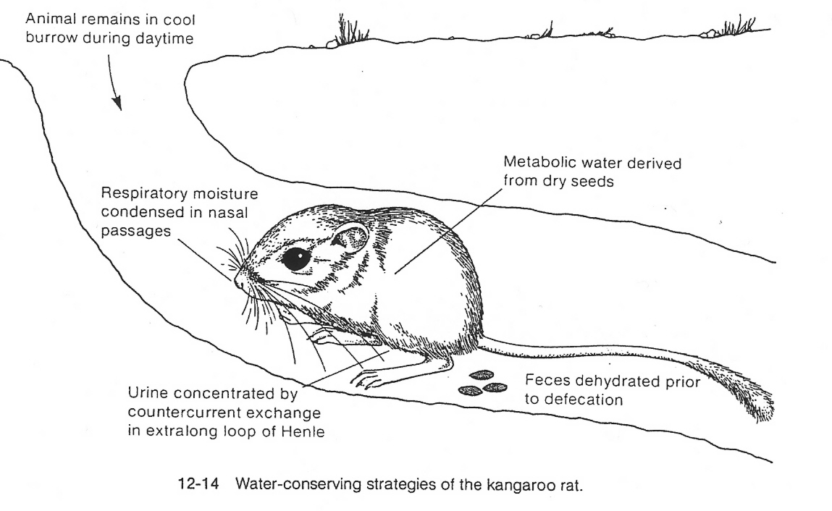

2

**Station 24 – Capybaras**

1. What are Capybaras known for?
2. What is the term for how they eat? What does it mean?
3. Where are they found?

**Station 25 – Pocket Gophers**

1. What is their most characteristic feature?
2. What is the term for where they are found? What does it mean?

**Station 26 – California Deer Mouse**

1. What does the work Peromyscus mean?
2. What is it notorious for?

**Station 27 – Norway Rat**

1. What are the only Norway rat-free zones? Why are they not there?
2. Where did they originate? What is the only other mammal that is more successful?

**Station 28 – Antelope Ground Squirrel**

1. How do they hold their tail? What do they do this for?
2. What is unique about this species of rodent?

**Station 29 – Chipmunk**

1. What are the four main calls in chipmunks?

**Station 30 – Order: Lagomorpha**

1. What animals does this order include?
2. How are they different from rodents?
3. Why do they eat their own feces? What is this process called?
4. When did they first appear in the fossil record?
5. Be able to recognize the following examples: Black-tailed Jackrabbit (specimen), Cottontail (specimen), Pika (Picture)
6. What are Black-tailed rabbits known for?
7. What is the Desert Cottontail’s anti-predator behavior?
8. Pikas do not hibernate. What are their food piles called? What are they an indicator of in North America?

**Station 31 – Order: Dermoptera**

1. What are the gliding membranes called?
2. What are they similar to in their breeding habits? What do they use as a pouch?

**Station 32 – Order: Scandentia**

1. What do they have in common with primates?
2. What kind of studies are they often used for?

**Station 33 – Order: Primates**

1. What characteristics are shared by all primates? What do most have?
2. When did primates arise?

**Station 34 – Prosimians**

1. What is included in this group?
2. What do they lack? Why?
3. What do they all have in common?

**Station 35 – Old World Monkeys**

1. What is included in this group?
2. What do they all have in common?
3. Be able to recognize the specimen in the Meek Museum.

**Station 36 – New World Monkeys**

1. What is included in this group?
2. What do they all have in common?
3. How did they arrive in the new world?

**Station 37 – The Great Apes**

1. What is included in this group?
2. What do they all have in common?
3. How do they differ from monkeys?

**Station 38 – Gorilla**

Be able to recognize the skulls of the gorillas

1. When do they separate from Chimpanzees?
2. Where are they found?
3. What do they eat?
4. How can you tell male from female?

**Station 39 - Orangutan**

Be able to recognize the skull of the orangutan

1. When do they diverge from the rest of the Great Apes?
2. Where are they usually found?
3. What type of social structure do they have?

**Station 40 - Chimpanzees**

Be able to recognize the skull of the different Chimpanzees

1. When did Chimpanzees split from the human branch of the family?
2. How are African Chimps different from Bonobo’s?
3. What is their type of locomotion called?
4. How much DNA do humans share with Bonobo’s?
5. What is the diet of the African Chimp? The Bonobo?

**Station 41 – The Hominids**

1. What is the one characteristic that separates hominids from other primates?
2. What other important characteristic developed?

**Station 42 – *Australopithecus afarenis***

Be able to recognize the skull of this species

1. What does the word Austlopithecus mean?
2. When do they first appear in the fossil record?
3. What basic hominid characteristics are found in this species?
4. Where are these fossils from?

**Station 43 – *Australopithecus africanus***

Be able to recognize the skull of this species

1. When do they first appear in the fossil record?
2. How are they similar to *A. afarensis*? How are they different? What primitive features did they have?
3. Where are these fossils from?

**Station 44 – *Austalopithecus******boisei***

Be able to recognize the skull of this species

1. When do they appear in the fossil record?
2. How does this brain size compare to the other Austalothecines?
3. What unique characteristics are found in this species?
4. Where are these fossils from?

**Station 45 – *Homo erectus***

Be able to recognize the skull of this species

1. When do they appear in the fossil record?
2. What does the name mean*?* What did they look like? From the neck down, who do they resemble?
3. Where was this species found?
4. What characteristics do they have?

**Station 46 – *Homo nenanderthalensis***

Be able to recognize the skull of this species

1. When do they appear in the fossil record?
2. In a 2010 study, the population dispersing across Eurasia, how much did the Neanderthals genes constitute?
3. How did their cranial capacity compare to modern humans?

**Station 47 – *Homo sapiens***

Be able to recognize the skull of this species

1. When do they appear in the fossil record?
2. What characteristics characterize humans?

**Station 48 – Order: Carnivora**

1. What is the one shared characteristic that lump all carnivores together?
2. What does the word carnivore mean?
3. Where and when did they evolve?
4. Where are they found in the world?

**Station 49 – Felines**

1. What type of feeders are they?
2. When do they appear in the fossil record?
3. How large are mountain lions? Are they a large or a small cat? How do you tell the difference?
4. How common are bobcats? What size are they? How do they hunt? Where are they found?
5. How large are African Lions? What lifestyle do they exhibit? What do they normally hunt?
6. How large are Tigers? What is their niche?
7. What size are Leopards? Are they a small or large cats? How do you tell a leopard and Jaguar? What is the secret to their success?
8. What are the unique characteristic seen in Jaguars? Where are they found?
9. How fast are Cheetahs? Where are they found?

**Station 50 – Canids**

1. What lifestyle do they usually possess?
2. When do they show up in the fossil record?
3. What is a Baculum? What is it used for?
4. What are coyotes known for? What is happening to their numbers? How much plant material do they eat?
5. What size are Gray Wolves? What was once its claim to fame? How do they hunt and what size prey can they take down?
6. What are male foxes called? What are female foxes called? How do they differ from other caninds? The Silver Fox is actually a color phase of which fox? What distinction does this animal have today?
7. Where are red foxes found? Where are gray foxes found? Where are arctic foxes found?

**Station 51 – Bears**

1. When did the bear show up in the fossil record?
2. What determines their size? What is their range in eating habits?
3. What size is the Polar Bear? What does their scientific name mean?
4. What are the two types of recognized brown bears? What is unique about brown bears?
5. How do you tell Black bears from Brown Bears? What is unique about the American Black Bear?
6. What makes up the Giant Panda’s diet? What is unique about the Giant Panda’s paw?

**Station 52 – Raccoon Family**

1. What common characteristic do most of them share?
2. When did they show up in the fossil record? Where are they restricted to?
3. What are the raccoon’s two most distinctive features?
4. What is the raccoon’s original habitat? Why have they extended their range?
5. What is unique about the Coati’s ankles?
6. What habitat are Red Pandas found in? What is its diet?
7. What is unique about the Ringtail compared to others in this family? What is its nickname?

**Station 53 – Weasel Family**

1. What do they all have in common?
2. When did they show up in the fossil record?
3. Where are Long-tailed Weasels found? What do they eat? How do they prefer their prey?

1. What do Pine Marten’s eat?
2. Where are minks found? What is their coat made of?
3. How do Wolverines capture larger prey?
4. What adaptations do Badgers have to protect themselves from attack? What are they known to hunt with?
5. What are skunks known for? How do they produce this?
6. What type of fur do Otters have? Where are they found? How do River otters differ from Sea Otters?

**Station 54 – Mongoose Family - Meerkats**

1. How are Meerkats different than other mongooses?
2. What behavior is often seen in Meerkats? What type of behavior is this considered?

**Station 55 – Hyena Family**

1. What do most hyenas eat? What adaptations to their digestive systems have been made so they can quickly digest their prey?
2. Why do they have a bear-like gait?
3. What is “unique” about the female sexual structures? Why do they have this structure?

**Station 56 – Order: Pinnepedia**

1. What does the name mean?
2. Where are they found?
3. What do their limbs look like?

**Station 57 – Seals and Sea Lions**

Fill out the following Table

|  |  |  |
| --- | --- | --- |
|  | **Seals** | **Sea Lions** |
| **Front Flippers** |  |  |
| **Rear Flippers** |  |  |
| **Neck** |  |  |
| **Ears** |  |  |
| **Testicles** |  |  |

**Station 58 – Walruses**

1. What oceans are they found in? Where in the ocean are they found?
2. How are they recognized?
3. What do they eat?

**Station 59 – Eared Seals**

1. How do you tell male from female sea lions?
2. Where are California Sea Lions found?

**Station 60- Earless Seals**

1. How do they differ from eared seals? How can they help control their body temperatures?
2. What are Weddel Seals known for?
3. What do Crabeater Seals Eat? How do they do this?
4. Where do Leopard Seals hunt? What do they feed on? How are they similar to Crabeater Seals?
5. What are harbor seals known for?
6. What kind of reproductive strategy do Elephant Seals exhibit? What is sexual dimorphism? How large are the males? How large are the females?

**Station 61 – Perissodactyla**

1. How many toes do these animals usually have?
2. When did they show up in the fossil record?
3. How do they digest food?

**Station 62 – Horse Family**

1. What unique characteristic do they share with humans?
2. What is the only true wild horse today? Where are they found?
3. How do Zebra’s use their stripes to protect themselves?

**Station 63 – Tapiridae**

1. What is the name of the behavior these animals often represent (raising their snout and showing their teeth to pick up scents)?
2. Where are they found?
3. What are they often cited as evidence for?

**Station 64 – Rhinoceros Family**

1. What are Rhinos known for?
2. What is the shape of the **White Rhino’s** mouth and what is it used for?
3. How does the Black Rhino differ from a White Rhino?

**Station 65 – Cetartiodactyla**

1. What does this clade include?
2. Where did the name come from?

**Station 66 – Artiodactyla**

1. How many toes do these animals usually have?
2. When did they show up in the fossil record?

**Statin 67 – Pig Family**

1. How do they differ from others in this order?
2. When did they show up in the fossil record?
3. What teeth make up the tusks in Warthogs? What are the warts probably used for?
4. What did wild Boars evolve into?

**Station 68 – Peccary Family**

1. How do Peccaries differ from true pigs?
2. Where are Peccary found and why?
3. What are the two forms of anti-predator behavior seen in Peccaries

**Station 69 – Hippopotamuses**

1. What does their name actually mean?
2. Where are they found? What do they eat?
3. What are they most closely related to? When did they split off?

**Station 70 – Camel family**

1. How do camels differ from other hoofed animals?
2. What other adaptations to their environment do they have?
3. How long can they go without drinking? How much can they drink at one time? How much water (%) can they lose?
4. What are the two different species of camel and how do you tell them apart?
5. What two well-known members of this family live in South America and what are they used for?

**Station 71 – Deer Family**

1. What animals are included in the deer family?
2. What do they all have (except one group)? What are they made of? What are they used for? What happens to them when they are done?
3. How are Sika deer different than other deer?
4. What are fallow deer known for? Why are they so widespread?
5. What are Chital deer associated with? What do each animal get from this relationship?
6. Where do Rusa deer get their name?
7. What ritual does Red Deer go through?
8. What is the other name for Elk? What does this word mean?
9. Where are White-tailed deer found? Where are Mule deer found?
10. What limits a moose’s daily feeding time? How do they meet their daily energy requirements? How do they meet their daily salt requirements?
11. What characteristic behavior is seen in Caribou? Why do they do this behavior?

**Station 72 – Giraffe Family**

1. How many cervical vertebrae do giraffes have?
2. Why did the long neck evolve?
3. How are their teeth adapted for eating leaves off acacia trees?
4. What do Okapi have in common with giraffe? Where are they found?

**Station 73 – Bovidae Family**

1. What do all bovidae have in common?
2. What belongs to this family?
3. When did they show up in evolutionary history?

**Station 74 – Pronghorn Family**

1. What are pronghorns known for?
2. What is unusual about Pronghorns compared to other Northern latitude ungulates?

**Station 75 – Cattle Family**

1. What do they eat and what is their best sense?
2. Be able to recognize the following species: American bison, Cape buffalo, the water buffalo, the Dwarf buffalo, the Asiatic buffalo and the Banteng.

**Station 76 – Small Antelope**

1. What does the name duiker mean? Why did this animal get that name?

**Station 77 – Spiral-horned Antelope**

1. What do they all have in common? What are they made of? Why are they twisted?
2. What do they eat? Why?
3. Why are bushbuck considered the most dangerous medium-sized antelope?
4. Kudu and Eland are said to be what type of feeders? What is unique about Kudu?
5. What is the name of the structure in Eland that hangs down from its neck? What is it used for?

**Station 78 – Grazing Antelope – Open Woods**

1. How do impala escape predators?
2. What are Blesbok not good at?
3. What is another name for Wilderbeest? In East Africa, what claim do wildebeest have? How do they escape predators?
4. How do Hartebeest escape predators?

**Station 79 – Grazing Antelope – Wetlands**

1. What do both sexes of Western Kob have?
2. What does the Reedbuck do when startled or attacked?
3. What do Waterbuck release when they are sexually excited? What name is given to them?
4. Where do Lechwe go to escape predators? What adaptation do they have to help with this?

**Station 80 – Grazing Antelope – Horse-like**

1. Where are Gemsbok found and how do they get water?
2. How do Fringe-eared Oryx tolerate periods of extreme temperature?
3. How do Roans fight?
4. What do Sable Antelope use their horns for?

**Station 81 – Grazing Antelope – Gazelles**

1. What is the name of the behavior seen in Springboks to avoid predators?
2. What is the Grant Gazelle known for? What is the cause of this situation?
3. How do Gerenuk feed?

**Station 82 – Dwarf Antelope**

1. What is the reason for their small size?
2. What is the type of feeding seen in dik-diks?

**Station 83 – Goat Antelope**

1. Where are goat antelope usually found?
2. Where did Musk Ox get their name? What is this substance used for?
3. How much do Big Horn Sheep horns weigh? What must they do every three days?
4. What habitats are Mountain goats found in? How do mountain goats stay on the steep hills? What pitch are these hills?
5. Why are Chamois successful? What do they do during fights?
6. What is actually happening in most fights between Himalayan Tahrs?
7. What does the physical adaptation give Ibex?
8. What is the Mouflan thought to be?

**Station 84 – Order: Cetacea**

1. What are the two main types of Whales?
2. How do you tell them apart?
3. Be able to identify the following examples: Blue Whale, Minke Whale, Pigmy Sperm Whale, Sperm Whale, Beluga Whale, Bottle-nosed Dolphin, White-sided Dolphin, Humpback Whale and Orca Killer Whale.

**Station 85 – Order: Chiroptera**

1. How many mammalian species are bats?
2. How are they unique?
3. How do vampire bats feed?
4. What do pallid bats eat?
5. What are Western Pipistrelle Bats known for?
6. Know the following skulls: Vampire and Fruit Bats

**Station 86 – Order: Insectivora**

1. What do they eat?
2. What characteristics do they have?
3. Know the examples: Moles and Shrews

**Station 87 – CLASS: MAMMALIA – INTERNAL FEATURES**

|  |  |  |
| --- | --- | --- |
| **System** | **Structure** | **Function** |
| **Digestive System** | **Esophagus**  **Stomach**  **Intestine**  **Liver**  **Pancreas**  **Spleen** |  |
| **Excretory System** | **Kidneys**  **Urinary Bladder** |  |
| **Circulatory System** | **Atria (2)**  **Ventricle (2)**  Double Circuit system (whole system)  Compare to bird (Why the difference in size?) |  |
| **Respiratory System** | **Lungs**  **Diaphragm** |  |
| **Nervous System** | Olfactory lobe  Cerebral hemisphere  Cerebellum  Medulla Oblongata |  |
| **Reproductive System** | Ovaries or Testes |  |

**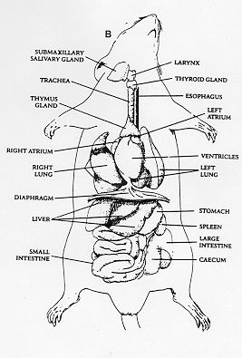**

**Station 88 – Animal Sounds – Mammals**

Be able to recognize the songs from the following Mammals.

Harbor Seal

California Sea Lion

California Ground Squirrel

Coyote

Mountain Lion

**Station 89 – Mammal Orders**

|  |  |  |
| --- | --- | --- |
| **Order** | **Description** | **Characteristics** |
| Order: Monotremata | Egg laying mammals |  |
| Order: Marsupialia | Pouch bearing mammals |  |
| Order: Proboscidea | Long, muscular trunk |  |
| Order: Hyracoidea | Shrew Mice |  |
| Order: Tubulidentata | Pig-like with a tubular snout and long ears |  |
| Order: Sirenia | Aquatic herbivores, possessing fin-like forelimb |  |
| Order: Xenarthra | Have reduced or no teeth |  |
| Order: Artiodactyla | Possesses hooves with an even number of toes |  |
| Order: Cetacea | Marine forms with fish-shaped bodies, paddle-like front limbs |  |
| Order: Perissodactyla | Possesses hooves with odd numbers of toes |  |
| Order: Carnivora | Possesses sharp, pointed canine teeth and molars |  |
| Order: Chiroptera | Adapted for flying |  |
| Order: Insectivora | Insect eating animals |  |
| Order: Pholiodata | Anteaters with scaly skin |  |
| Order: Rodentia | Possesses chisel-like incisor teeth |  |
| Order: Lagomorpha | Possesses chisel-like incisors, hind legs longer than forelegs for jumping |  |
| Order: Dermoptera | Large gliding mammals |  |
| Order: Scandentia | Larger shrew-like animals with teeth |  |
| Order: Primates | Opposable thumb, binocular vision |  |