Name: _____________________________

Marine Biology Article #1: Tsunamis (5 pts)
Answer the following questions after reading the article: Tsunamis: how the form. By: Alexandra Black, Published by Australian Geographic, March 18, 2011
1. According to Professor Dale Dominey-Howes, what two factors determine how big a tsunami will be?
____________________________________________________________________________________
2. What percentage of tsunamis are caused by underwater earthquakes? What are some of the other ways that tsunamis can be formed? ___________________________________________________
________________________________________________________________________
4. According to Professor Dale Dominey-Howes, what magnitude must an earthquake be in order to trigger a tsunami? ___________________________________________________________
5. Why do shallow earthquakes tend to cause more damage than deeper ones? __________________
________________________________________________________________________
________________________________________________________________________
6. How far below the ocean floor was the earthquake that caused the tsunami in Japan in 2011? ______
________________________________________________________________________
7. How does the wavelength and wave period differ between tsunamis and normal ocean waves? _____
________________________________________________________________________
________________________________________________________________________
8. Describe how the tsunami monitoring system detects tsunamis? __________________________
________________________________________________________________________
________________________________________________________________________
9. How fast can a tsunami travel when at sea? Multiple the km/h by 0.62 to determine the mile per hour.
____________________________________________________________________________________
10. According to the Anatomy of a Tsunami figure, what do tsunamis actually represent? __________
________________________________________________________________________
11. Why do ships on the ocean rarely notice when a tsunami passes under them? ________________
________________________________________________________________________
12. How much did the sea floor move during the 2004 Indian Ocean tsunami? __________________
________________________________________________________________________
13. What causes tsunamis to flood land for so long and travel so far inland? _______________________
________________________________________________________________________
14. According to Professor Dale Dominey-Howes, what areas are most vulnerable to tsunamis? Why?
________________________________________________________________________
________________________________________________________________________
15. What are some ways that the wave energy can be reduced? ____________________________
________________________________________________________________________

Tsunamis: how they form
BY ALEXANDRA BACK |MARCH 18, 2011
Tsunamis were virtually unheard of in the mass media until the catastrophic monster waves that struck on Boxing Day in 2004. But large events like the earthquake and tsunami in Chile in 2010 and the recent Japanese disaster have put tsunamis back into the public consciousness.
Though they have occurred through history, their unpredictability and infrequency make them difficult to study. Scientists know what causes them and, following the advent of tsunami warning centers, can measure how fast they travel and when they may reach distant shores.
But because each tsunami is unique and not all earthquakes produce them, there is still little known about where the worst waves will strike and how big they will be. "There's no hard or fast rule - it basically depends on how big and how shallow the quake is," says Professor Dale Dominey-Howes, co-director of the Australian Tsunami Research Centre and Natural Hazards Research Centre at UNSW.
Tsunamis: How they form
Underwater volcanoes erupting, icebergs calving and in rare instances meteorites hitting the ocean have all produced the giant waves in the past. But very large underwater earthquakes are responsible for about three-quarters of all tsunamis.
"Broadly speaking earthquakes have to be a magnitude six or above to trigger a tsunami," Dale says. "And the closer to the sea floor an earthquake hits, the more likely it is to generate a tsunami."
This is largely because of the same principal as to why shallow earthquakes, like the Christchurch one, cause so much damage: a large amount of energy has a shorter distance to travel and less resistance to travel through.
A magnitude-9 earthquake for example, won't trigger a tsunami if it takes place hundreds of kilometers below the earth's surface. But the earthquake that size off the coast of Japan last week was only 24 km below the ocean floor.
Most normal ocean waves have a wavelength (the distance between crests of consecutive waves) of at most 30 to 40 m, but tsunamis are completely different, says Dale. "They have wavelengths of 100 to 200 km and a wave period of tens of minutes to nearly an hour."
Indian Ocean tsunami tracking system - a new technology
Once a tsunami has been generated, scientists can accurately forecast the when (to within a couple of minutes) and the where it will hit coastline. Prior to the 2004 tsunami, though, there was no tsunami warning center in the Indian Ocean, so warnings issued were slow or non-existent.
To track tsunami wave movements, scientists rely on a series of complex monitoring systems, starting with devices on ocean floors that are able to measure an increase in pressure at that point. This information is sent to buoys on the surface, which is passed to satellites and then to monitoring stations on land.
"Basically, if you dump an extra meter of water on the water column you can measure that increase in pressure," says associate professor Stephen Roberts from the Mathematical Sciences Institute at the ANU where he works on modelling tsunamis.
From speeds of up to 800 km/h out at sea, tsunamis slow down significantly on approach to shore. Despite this, it is difficult to forecast how the wave will behave on arrival.
"I'm actually not so much worried with the deep ocean modelling, that's pretty under control...but what happens when the actual wave comes into shore," Stephen says. "You get all sorts of weird complex behavior, waves that are bouncing off headlands and you can get amplification of the waves."
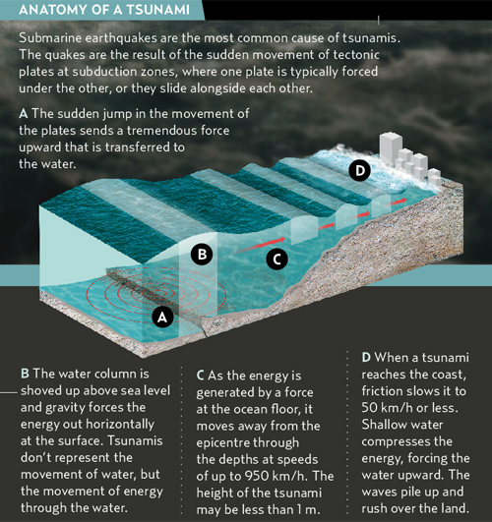
Tsunamis: What happens as they approach land
A boat out at sea would barely notice a tsunami passing beneath it, because the height of the wave in deep water is rarely over a meter. That's because below it, like the tip on an iceberg, is an enormous column of water - usually shifted from a large and sudden displacement of the sea floor. The 2004 Indian Ocean tsunami, for example, resulted from most of the 1600 km section of the sea floor moving 10-15 m sideways and being lifted 4-5 m.
This column, from the top of the wave to the sea floor, rises and falls as the massive amount of energy is pushed along from the source. As the wave moves toward land and the sea becomes shallower, this column of water is squeezed upwards, increasing in height as ocean floor turns into beach.

"The front end of the wave slows down as it reaches the coast and the back end, which is still going very fast, is powering up behind the front end," Dale says. "That's why tsunamis flood land for many, many minutes and can go many kilometers inland."
Among the most vulnerable areas of a coast are funnel-shaped harbors and bays as the incoming flow of water bounces back in on itself from the enclosed shores. "Embayments are very problematic for focusing the tsunami energy and waves, so if you've got indented coastlines, like harbors, like embayments, tsunamis tend to get funneled into those," Dale says.
"The safest places are high ground with strong cliff lines and where there is very deep water off the coast line, as tsunamis can't get big where there is very deep water,"
Natural vegetation like mangroves and large coral reefs can also act as barriers and can start to reduce the wave energy. But often the lowest-lying areas of the coast - and the most vulnerable to tsunamis - are often hubs of urban development.

