Name___________________________
Homework Assignment #1 - Cellular Respiration (5 pts)
Write the chemical equation for cellular respiration below.

What is the purpose of cellular respiration?
_____________________________________________________________________________________
What does ATP stand for? ______________________________________
What does ADP stand for? ______________________________________
When a phosphate molecule is added to an ADP to form ATP energy is ____________. When a phosphate molecule is released from ATP to for ADP, energy is _____________.

Fill in the name of the four main steps in the cellular respiration process and their locations in spaces below.
Name of Step Location
_______________________________ __________________________________________________
_______________________________ __________________________________________________
_______________________________ __________________________________________________
_______________________________ __________________________________________________

Use your lecture handout and textbook to fill in the blanks with the correct terms or numbers.
The first stage of cellular respiration is known as ________________, where one ___________ molecule is broken down into two ________________ molecules, resulting in the net gain of ___ ATP.
The second stage of cellular respiration is known as the ______________ phase, and pyruvate is combined with coenzyme A to form ______________________. Two __________ molecules and carbon dioxide are the products of this second stage of the cellular respiration process.
The third stage of cellular respiration is known as the ________ cycle. The breakdown of one glucose molecule results in two cycles, which yields _____ carbon dioxide molecules, ______ NADH molecules, _____ ATP, and _____ FADH₂ molecules.
The last stage of the cellular respiration process is made up of two parts, the ________ ________ chain and ____________________. In this last stage, ___________ are released from NADH and FADH₂ and power the active transport of hydrogen ions against their concentration and electrical gradients. The hydrogen ions then fall down their electrochemical gradient through a specialized enzyme known as ______________________, which uses the energy from the falling hydrogens to attach a phosphate group to _______ to form ATP.
Fill in the products of each step or the name of the missing step in the cellular respiration process. Write the number of ATP produced by each step of cellular respiration in the below each step.
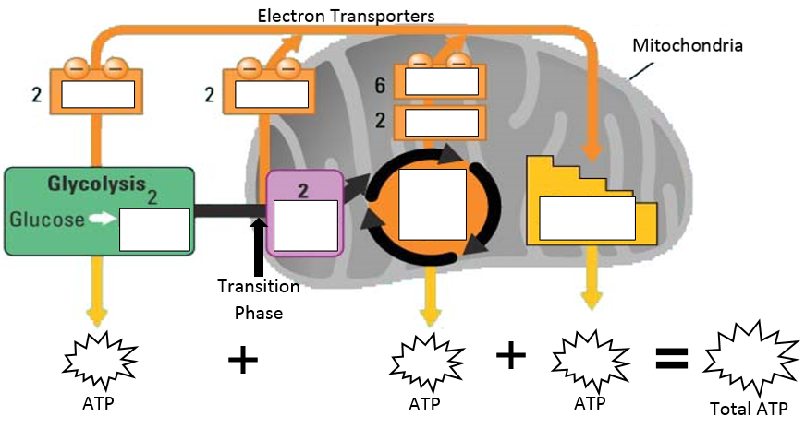

For letters A through H, fill in the name of the processes, molecule or enzyme.

A. B.
