Name: _______________________

Aquarium of the Pacific Extra Credit (20 pts)

Outside Exhibits: Pathways to the Pacific (to the left, behind the shark exhibit)
- What is a watershed?

- What has transformed the San Pedro Water Shed?

- Create a pie chart showing how much different users consume (Ag., Government & Schools, Commercial & Industrial, Residential)

- List two ways you can conserve water at home.

- What are some of the consequences of declining water?

  - What are some solutions? (list at least two)

Outside Exhibits: Sharks
- Touch a shark in one of the touch tanks. How does the skin feel? What kind of scales are found on the surface of the shark?

- How can you tell a male from a female shark?

- What are three senses found in sharks?

- What is shark fining?

- Name three types of sharks that you observed in the tanks.

Outside Exhibits: Seals and Sea Lions: What are three differences between seals and sea lions?

Seals | Sea Lions

Outside Exhibits: Magellanic Penguins
- Watch the penguins swim. What body parts do they use to move through the water?

- Draw a sketch of the face of a Magellanic penguin. Indicate which parts of the face are white, black, and pink on your drawing.

- What percentage of all penguin species are either vulnerable to or threatened with extinction.

- Why is overfishing a threat to penguins?

- List at least 5 predators of penguin eggs.

- What type of pollution are penguins especially vulnerable to?

Moving Inside from the Skate and Ray Exhibit (Upstairs)
- Garden eels are in an exhibit just inside the doorway. How can you tell that the garden eels are plankton feeders? (Look at the behavior and the anatomy of these animals to answer this question.)

- To the left of the garden eels is information on the Vaquita. What is the Vaquita and why are Vaquitas threatened with extinction?

Northern Pacific Gallery
- Describe the shape of a Common Murre's egg and explain how this shape ensures the egg's safety.

- How are puffins adapted to their environment? (Watch them swim and look at their anatomy to answer this).

- What hemisphere are puffins found in?

- Look at the tank containing Common Murres, Horned Puffins, and Crested Auklets. Which has the:
  - Thickest bill? ___________________
  - Reddest feet: ___________________
  - Which bird sits highest on the cliff: _________________

- List the common names and phyla of two invertebrates that you observed in this gallery.

- Observe a living jellyfish and describe how it swims.

Coastal Corner
Observe and touch the organisms in this touch tank. State the common name and phylum of two organisms in this tank. Describe one adaptation that allows the organism to live in the intertidal.
Common Name | Phylum | Adaptation

Sea Otters: Watch the sea otters swim and play in the tank. Note that they spend a great deal of time grooming their fur.
- How much do sea otters typically eat and what food items do they eat? (Sea Otter Challenge and What's for Dinner display info)

- Why are predators such as sea otters important to coastal environments? (Sea Otter Challenge and Keystone Species display info)

Tropical Pacific Gallery
- Fish Locomotion
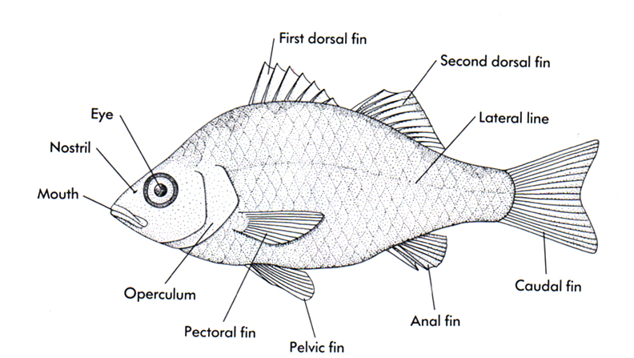
  - Observe TWO different fish species living in this gallery and complete the following:
  - In the table on the next page, state the name of each fish. (Use fish I.D. guide in the visitors guide to assist you with fish names)
  - State what fins it is mainly using in order to swim or move around with (use the diagram to the right determine the names of the fins)
  - Describe its habitat (ex. pelagic (above sea floor), benthic (on sea floor), within reef, etc.). In order to determine habitat, observe where the fish spends most of its time within the tank.
  - Draw the fish that you observed.

Name of fish #1: | Name of fish #2:
Fins used | Fins used
Habitat | Habitat
Drawing | Drawing

Tropical Pacific Gallery - Coral Reefs
- Look at a living coral polyp. What are the tiny photosynthetic organisms that live in coral polyps?

- Why are coral reefs declining?

- What is coral bleaching?

Tropical Pacific Gallery - Sex Change Exhibit
What is the common name of a fish that goes through a sex change?

Tropical Pacific Gallery - El Nino
- What does El Nino mean?

- What happens during an El Nino?

- How often do El Nino's occur?

Whale Display Touch Screen
- Listen to the call of a humpback whale. Describe what the call sounds like.

- What is a spectrogram?

Go to the ground floor and find the wall where there in information on the blue whale:
- How long is the blue whale? ________________________________________

- How much milk can a newborn blue whale drink in a day? _______________

- How many pounds can a blue whale gain when nursing? _________________

- How many gallons of water can enter a blue whale's mouth in one gulp? _____

Vanishing Animals: Loss of Biodiversity
- Which animals on the “10 animals at risk of extinction” and “10 animals in North America at risk of extinction” are marine animals/plants?

- Why are animals disappearing?

- Vanishing Everglades- What was the consequence of the ecological extinction of the Everglade Alligator?

- Endangered Species- Coral reefs cover only ____% of earths surface but provide homes for about ____% of species.
  - Which fish help graze algae from coral surfaces to reduce competition for sunlight and space?

  - What is responsible for the decline of coral reefs?

- Vanishing Atlantic Cod: Atlantic cod keep ice crystals from forming in their blood by producing a protein called _______________.
  - What led to their commercial extinction?

- What is “sustainable agriculture”?

- Watch the video that’s showing. Change is normal when it comes to evolution. However the rate of extinction today is higher than ever before. What is contributing to this?

